Supplementary figures
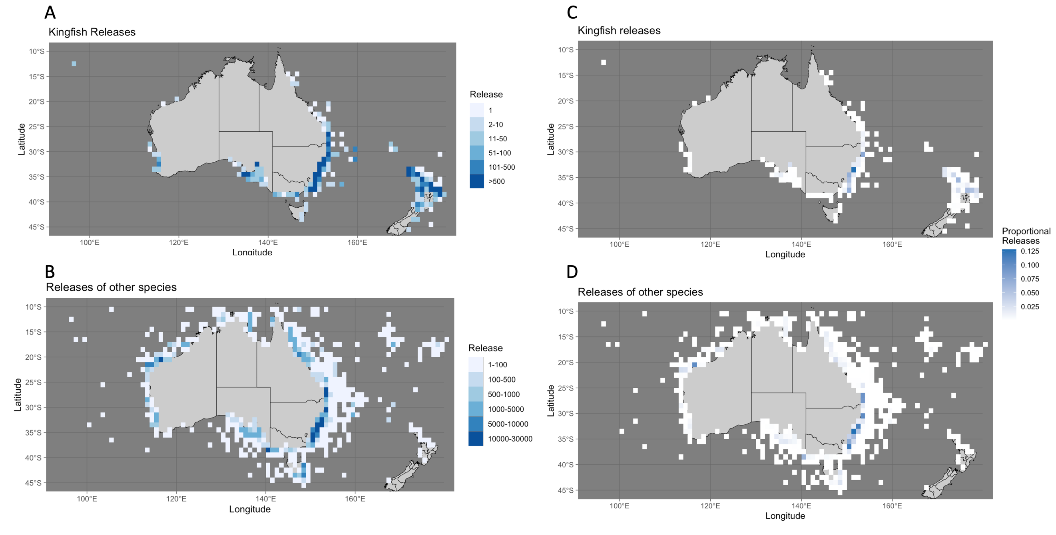
Supplementary figure 1: Tagging effort of kingfish in comparison to all other marine species tagged in NSW DPI GFTP. The total number of releases of kingfish (A) and other species (B) are grouped into 1-degree latitude- longitude grids, as well as the proportion of releases of kingfish (C) that occurred in each grid out of the total number of kingfish tagged throughout the duration of the GFTP (1974-2022) analysed within this study. To directly compare the proportion of kingfish released in each 1-degree latitude-longitude grid to the tagging effort of other species, the proportion of all other species targeted in the study, in relation to the total number of species (excluding kingfish) that were tagged from 1974-2022 is also displayed (D).
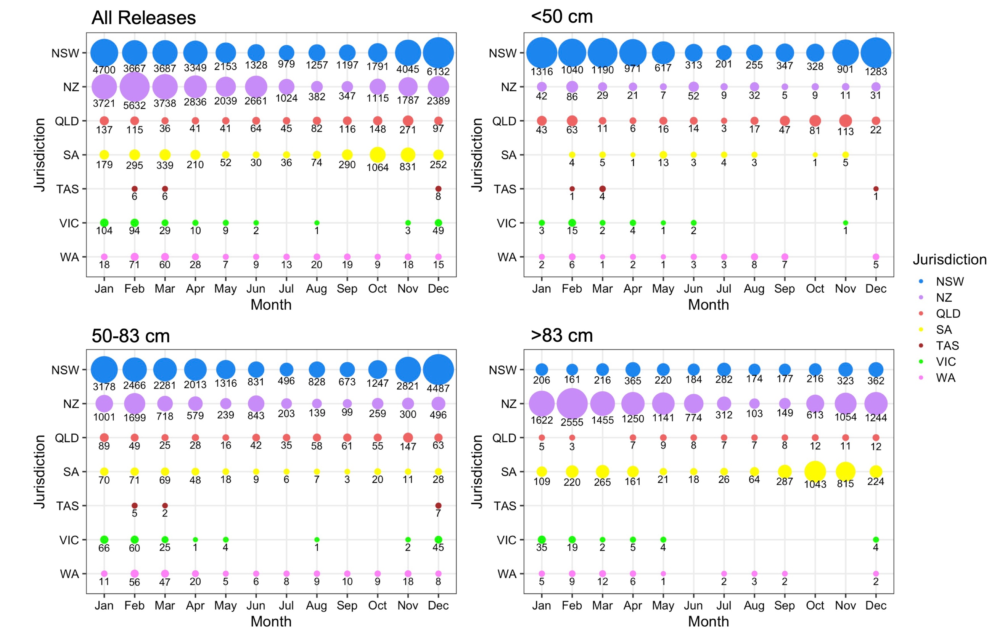
Supplementary figure 2: Number of kingfish that were released each month in either the NSW or NZ GFTP. Releases are grouped by the jurisdiction that the fish was released in, as well as the size of the fish at the time of release.
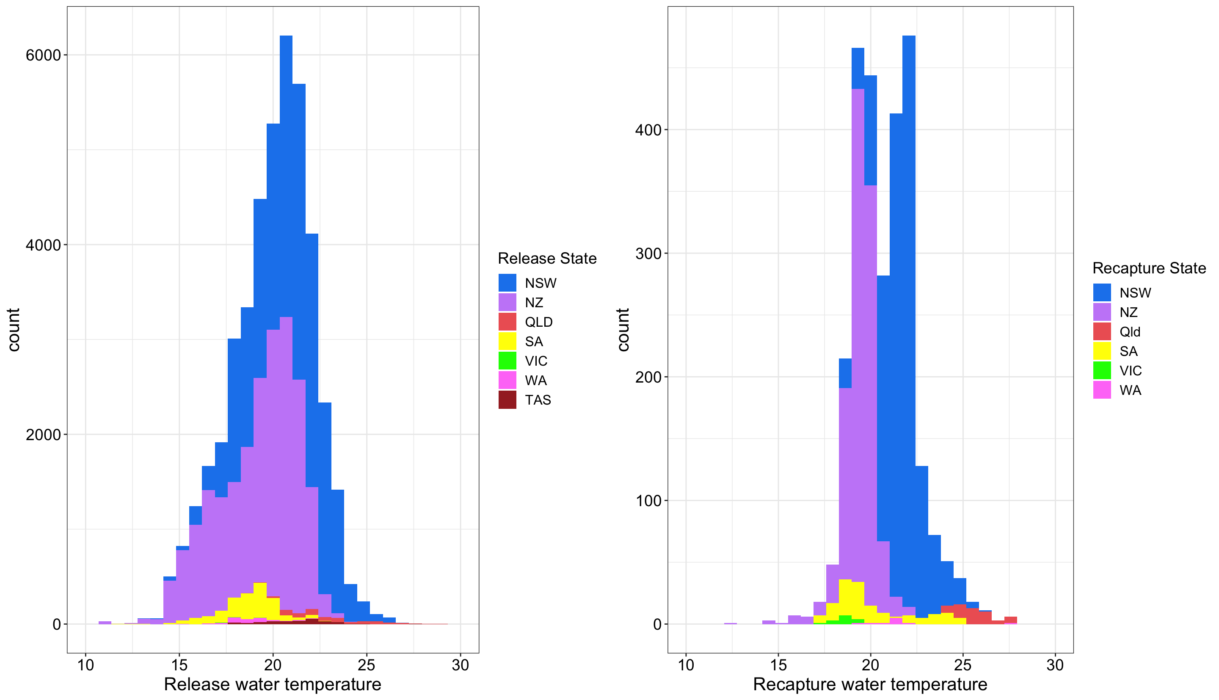
Supplementary figure 3: Water temperature (°C) at the time of release and recapture. Water temperature is modelled for 2.5 metres depth for each release and recapture location using BRAN2020 ocean reanalysis models (Chamberlain et al. 2021b).
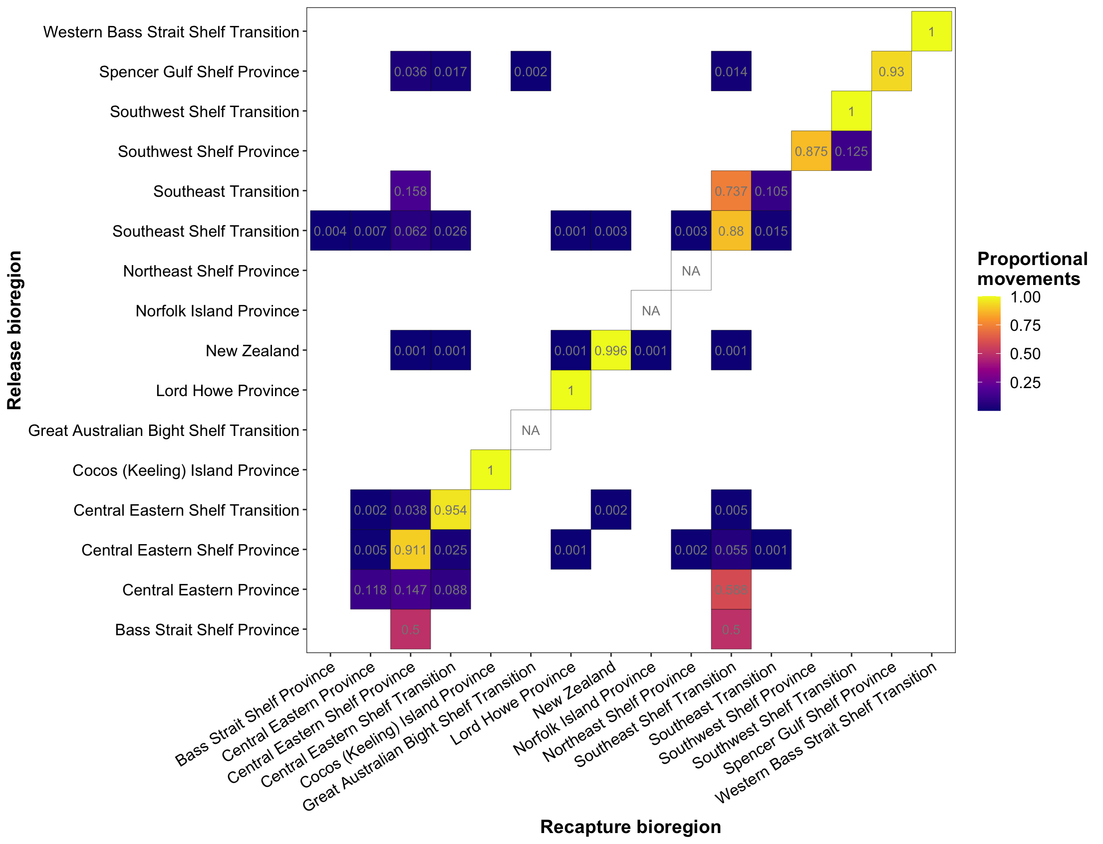
Supplementary figure 4: Connectivity matrices based on the movements of kingfish. Movements of kingfish are identified through the release location (y-axis) and the recapture location (x-axis). Numbers show the proportion of releases from each bioregion that were recaptured in each respective bioregion. Combinations of release and recapture bioregions where connectivity was not observed through either GFTP remain blank. The three NA squares indicate that no kingfish released as part of either GFTP was eventually recaptured, however those bioregions did have kingfish recaptured in them (hence they are displayed on both axis for ease of interpretation of results). Lighter coloured squares indicate higher level of connectivity between two bioregions, while dark coloured squares indicate there was some connectivity observed.
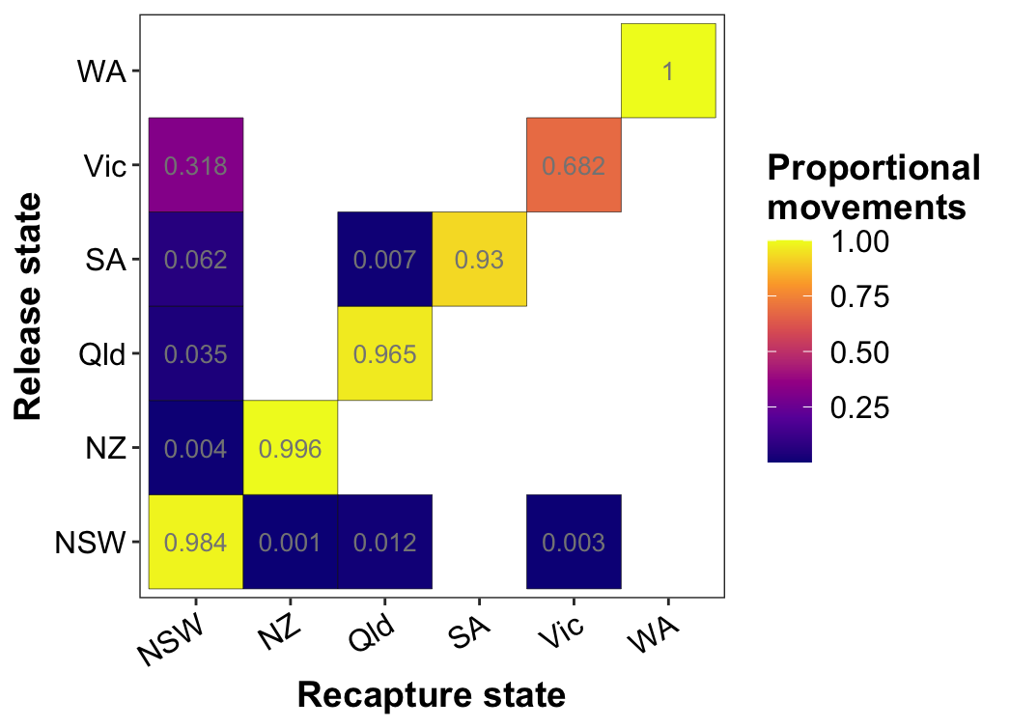
Supplementary figure 5: Connectivity matrices based on the movements of kingfish. Movements of kingfish are identified through the release location (y-axis) and the recapture location (x-axis). Numbers show the proportion of releases from each state jurisdiction that were recaptured in each respective jurisdiction. Combinations of release and recapture jurisdictions where connectivity was not observed through either GFTP remain blank. Lighter coloured squares indicate higher level of connectivity between two bioregions, while dark coloured squares indicate there was some connectivity observed.
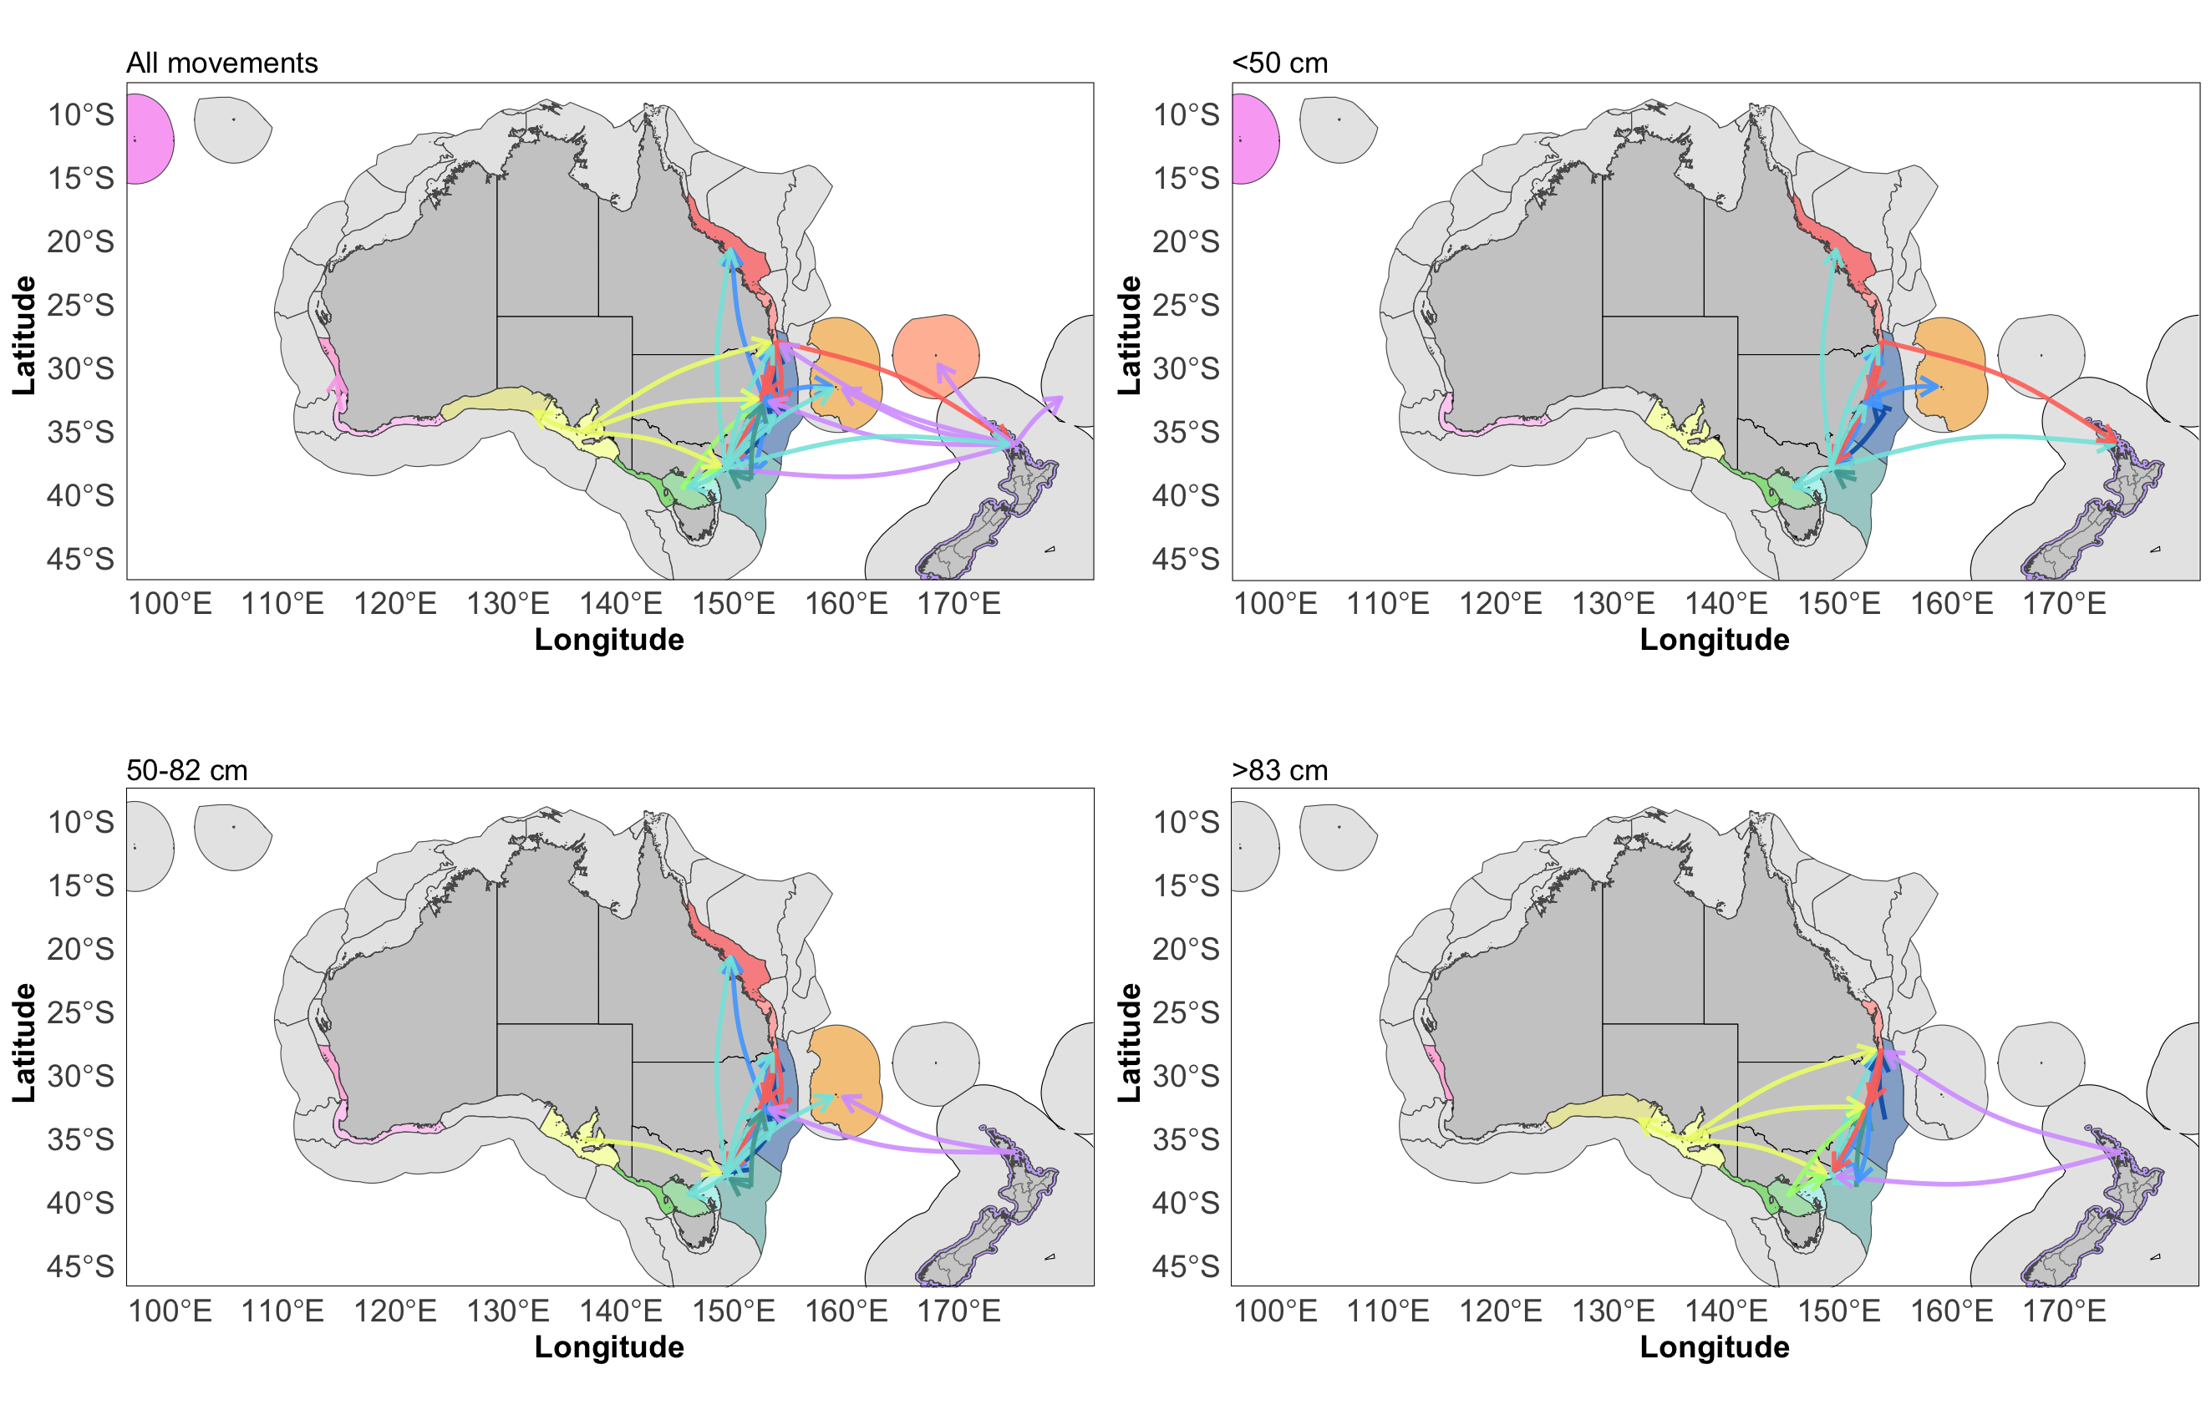
Supplementary figure 6: Connectivity of kingfish between bioregions, grouped by size at time of release. Release size (cm) is a combination of total and fork length but was not always able to be differentiated. Not all released fish had a length recorded at time of release, but may have at time of recapture, hence not all movements are displayed in the size at time of release networks.
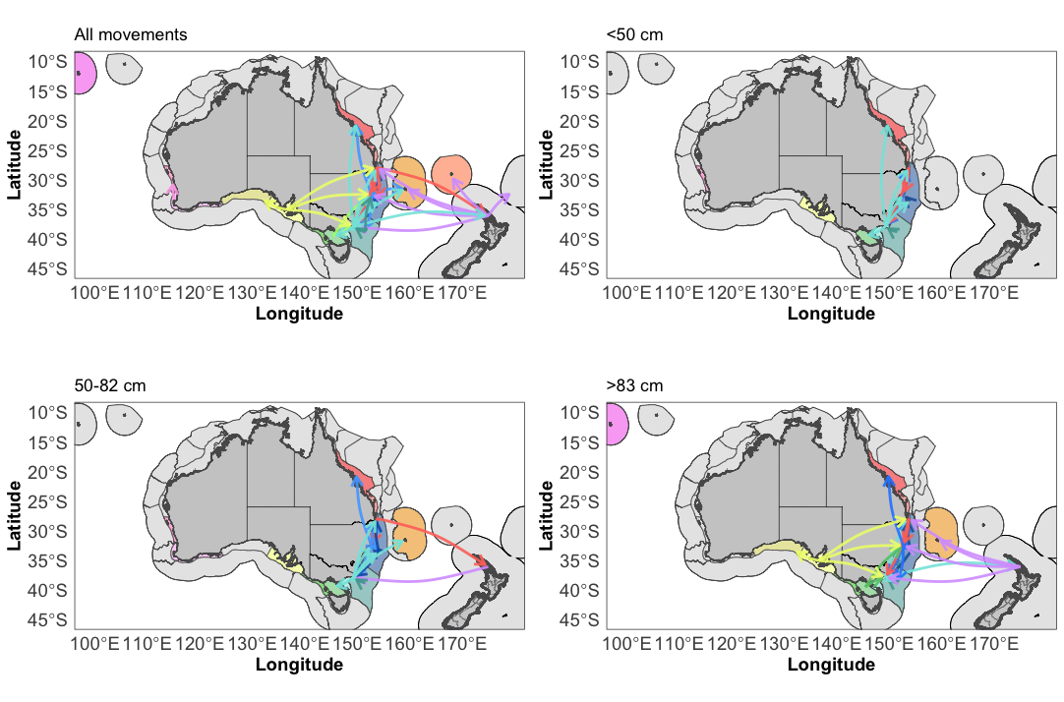
Supplementary figure 7: Connectivity of kingfish between bioregions, grouped by size at time of recapture. Recapture size (cm) is a combination of total and fork length but was not always able to be differentiated. Not all released fish had a length recorded at time of release, but may have at time of recapture, hence not all movements are displayed in the size at time of release networks.

Supplementary tables
Table S1: Node-level centrality measures derived from network analysis of tagged kingfish recaptures across provincial bioregions. In-degree is the number incoming movements from neighbouring nodes. Out-degree is the number of out-going movements to neighbouring nodes. Centrality is the number of edges (unique movements) connected to a node (sum of in-degree and out-degree), identifying whether elements of the network are more central or peripheral to the overall system. Betweenness demonstrates the number of shortest paths passing through a node, highlighting how likely a node or an edge is to be passed through when going from one node to every other node in the network, with a number of 1 meaning that all possible paths in the network cross through the node to get to another. Closeness is how close each node is to every other node of the graph (centrality to the network of movements), with values closer to 0 indicating shorter distances and those closer to 1 indicating larger distances, and therefore not central.

Bioregion | In-degree | Out-degree | Centrality | Betweenness | Closeness
Bass Strait Shelf Province | 1 | 2 | 3 | 0 | 0.04
Central Eastern Province | 4 | 4 | 8 | 0 | 0.042
Central Eastern Shelf Province | 8 | 7 | 15 | 0.044 | 0.067
Central Eastern Shelf Transition | 6 | 5 | 11 | 0.022 | 0.053
Cocos (Keeling) Island Province | 1 | 1 | 2 | 0 | NA
Great Australian Bight Shelf Transition | 1 | 0 | 1 | 0 | 0.03
Lord Howe Province | 4 | 1 | 5 | 0 | 0.045
New Zealand | 3 | 7 | 10 | 0.06 | 0.053
Norfolk Island Province | 1 | 0 | 1 | 0 | 0.033
Northeast Shelf Province | 2 | 0 | 2 | 0 | 0.04
Offshore New Zealand | 1 | 0 | 1 | 0 | 0.033
Southeast Shelf Transition | 8 | 9 | 17 | 0.112 | 0.067
Southeast Transition | 3 | 3 | 6 | 0 | 0.04
Southwest Shelf Province | 1 | 2 | 3 | 0 | 1
Southwest Shelf Transition | 2 | 1 | 3 | 0 | 1
Spencer Gulf Shelf Province | 1 | 5 | 6 | 0 | 0.045
Western Bass Strait Shelf Transition | 1 | 1 | 2 | 0 | NA

Table S2. Summary of the water temperature (°C) for the releases and recaptures within each jurisdiction. There were no recaptures recorded in Tasmania.
Release/recapture | Jurisdiction | Minimum | 1st quartile | Median | Mean | 3rd quartile | Maximum
Release | New South Wales | 13.34 | 19.32 | 20.87 | 20.71 | 22.11 | 26.7
 | New Zealand | 10.74 | 17.63 | 19.69 | 19.18 | 20.87 | 23.83
 | South Australia | 18.9 | 21.15 | 22.4 | 22.83 | 24.28 | 28.86
 | Queensland | 11.81 | 17.8 | 18.94 | 18.64 | 19.58 | 22.95
 | Tasmania | 17.54 | 17.54 | 17.61 | 17.97 | 18.11 | 13.12
 | Victoria | 15.02 | 18.12 | 18.54 | 18.72 | 19.39 | 22.3
 | Western Australia | 17.71 | 20.15 | 21.51 | 21.22 | 22.27 | 27.91
 | All releases | 10.74 | 18.61 | 20.22 | 19.95 | 21.43 | 28.86
Recapture | New South Wales | 18.57 | 21.06 | 21.17 | 21.65 | 22.15 | 25.64
 | New Zealand | 12.28 | 19.03 | 19.47 | 19.43 | 19.9 | 22.27
 | South Australia | 24.27 | 24.95 | 25.52 | 25.7 | 26.32 | 27.86
 | Queensland | 17.05 | 18.6 | 19.39 | 20.08 | 20.96 | 24.55
 | Victoria | 17 | 17.77 | 18.79 | 18.45 | 18.9 | 19.11
 | Western Australia | 19.65 | 20.68 | 21.46 | 21.67 | 21.62 | 27.62
 | All recaptures | 12.28 | 19.53 | 20.65 | 20.78 | 21.84 | 27.86
Overall combined |  | 10.74 | 18.70 | 20.25 | 20.00 | 21.48 | 28.86

