- Supplementary Figures:
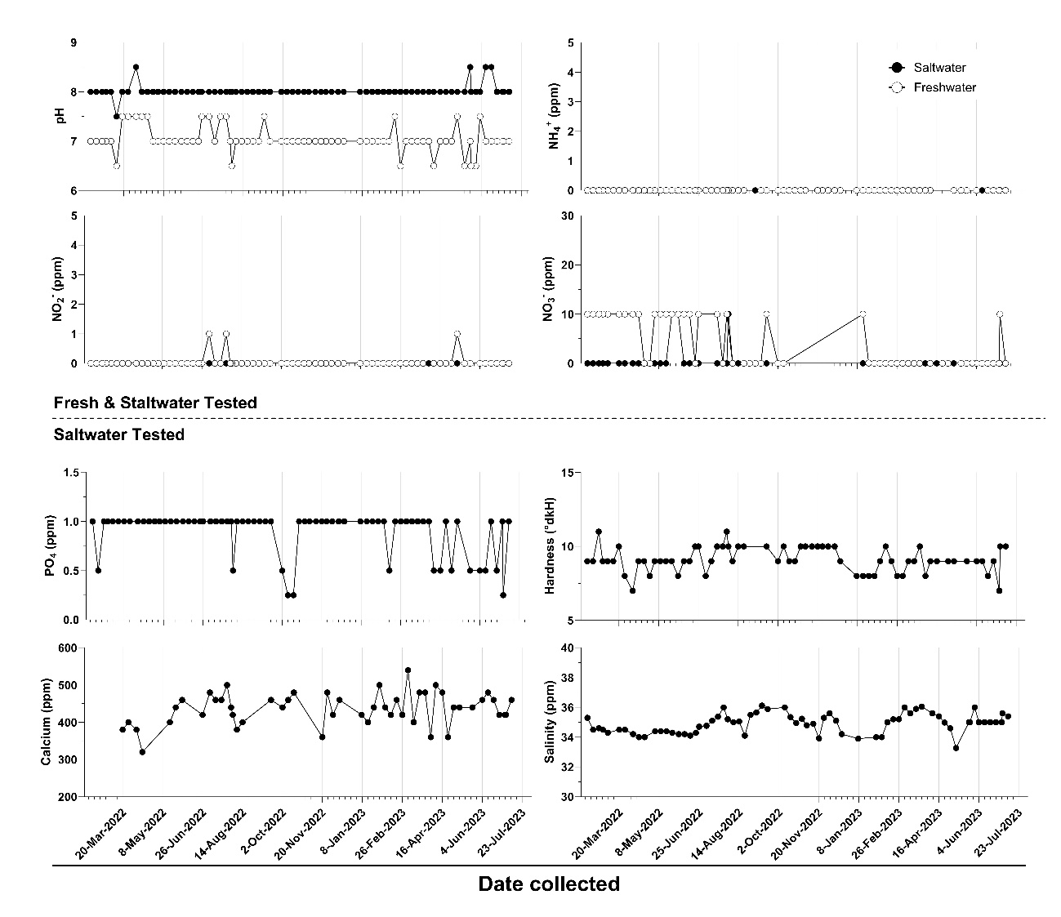

Supplementary Figure 1. Conditions within sampled research aquariums. The acidity (pH; measured in pH units) and concentration of ammonia (NH₄⁺), nitrite (NH₂⁻) and nitrate (NH₃⁻) in parts per million (ppm) were measured weekly in both the freshwater and saltwater research aquariums used to simulate environmental samples. The phosphate (PO₄; ppm), general mineral hardness (degrees of general hardness; °dkH), calcium (Calcium; ppm) and salt (Salinity; ppm) concentrations were recorded weekly for the saltwater research aquarium. Missing data points were typically due to global shortages of reagents

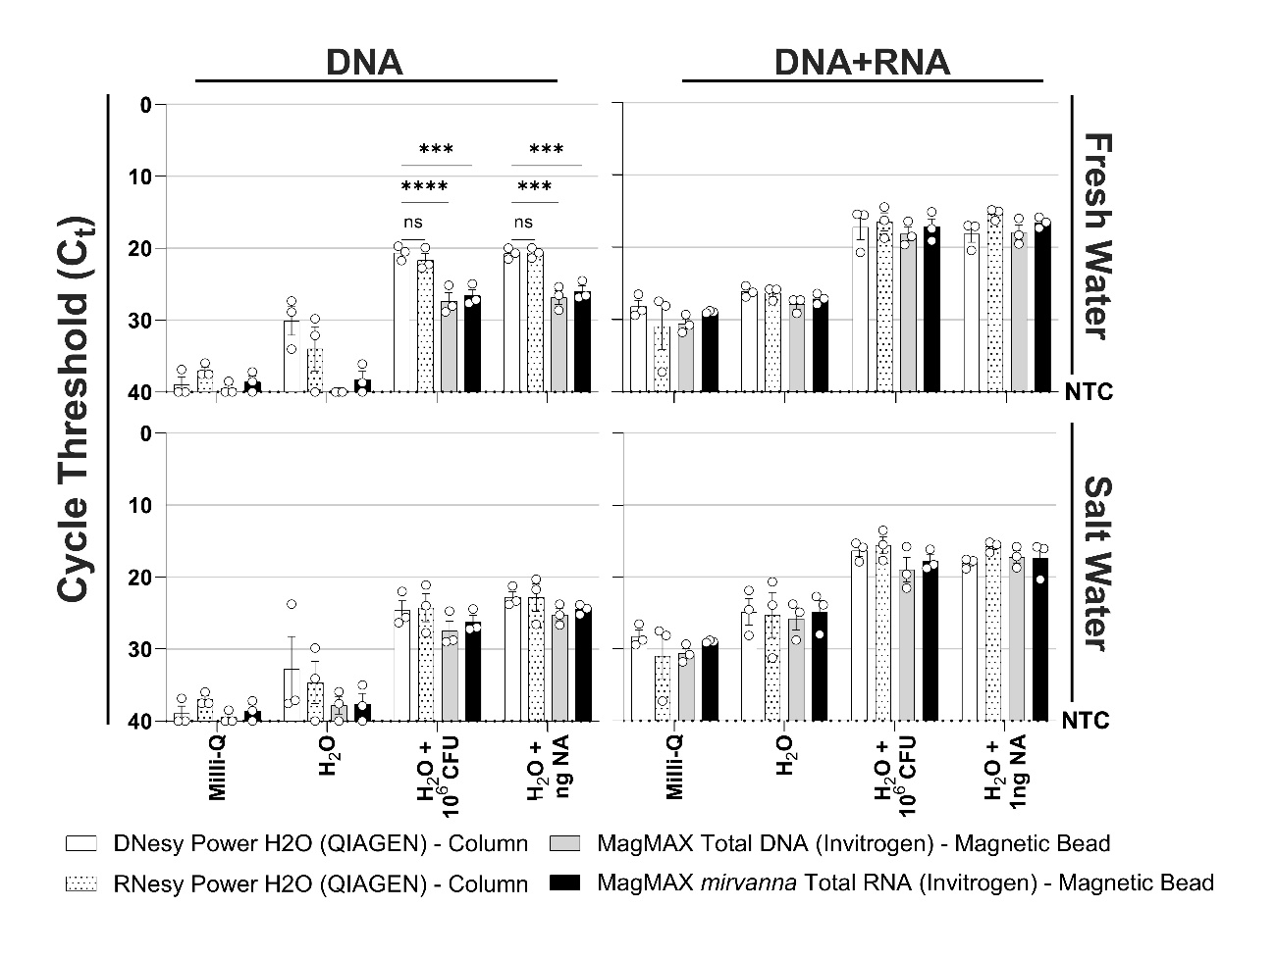

Supplementary Figure 2. Optimization of nucleic acid isolation kit for eDNA and eRNA microorganism detection: 10⁶ S. aureus colony forming units (CFU) or 1ng of nucleic acids (NA) were spiked into 500mL of freshwater or salt water, filtered with borosilicate glass filtration (GF/F) filters, and extracted with one of either DNeasy PowerWater kit (white bars), RNeasy PowerWater kit (white/spotted bars), MagMAX™ Total Nucleic Acid Isolation Kit (grey bars) or MagMAX™ mirvanna RNA Isolation Kit (black bars), then reverse-transcribed with Superscript IV (Invitrogen) and tested with 16S species-specific qPCR, alongside a sterile filtered water (MILIQ), and background (H₂O) negative controls. Samples were either reverse-transcriptase negative representative of genomic DNA (DNA) or reverse-transcriptase positive representative of genomic DNA and 16S RNA expression (DNA+RNA). qPCR signal cycle threshold (Ct Value; Log₂ scale,) shown. Undefined results were given a value of 40. The no-template control (NTC) of the PCR was undefined. Data were compared with a two-way ANOVA with post-hoc Bonferroni’s multiple-comparisons test; (NS P > 0.05; *** P ≤ 0.001;  P ≤ 0.0001).. Triplicate replicate extractions with single reverse transcription reactions per extraction were performed Mean ± SEM of three technical replicates shown.

A
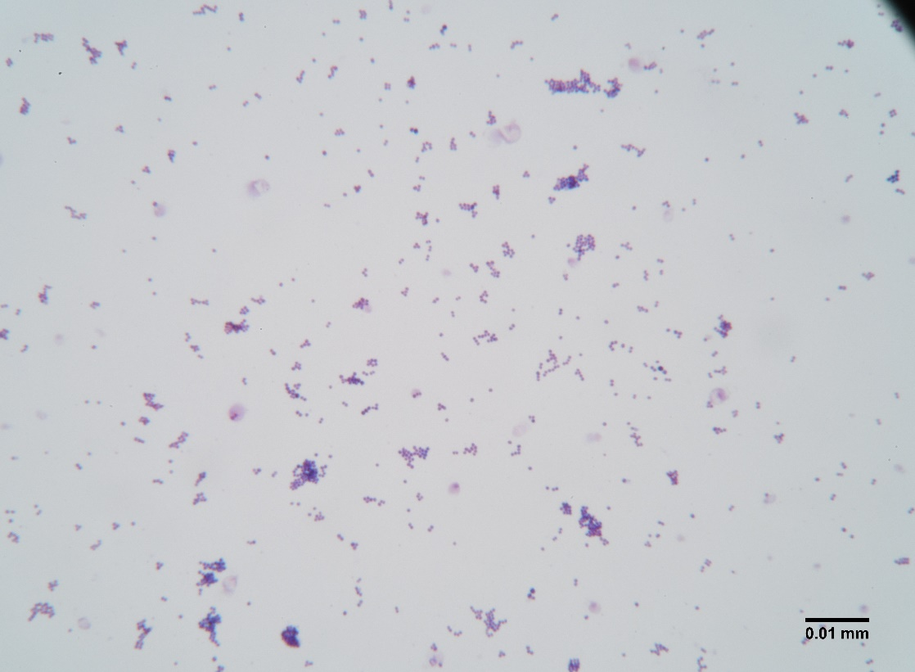
B
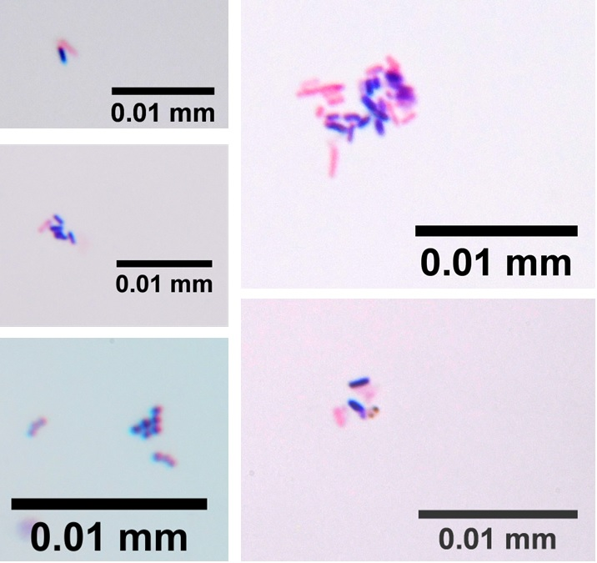
Supplementary Figure 3. Gram-stain of bacteria from freshwater. Representative images of Gram-stained bacteria isolated from 500 mL of water from sampled freshwater research aquarium. The specimen was concentrated to 100 μL by centrifugation, dried, Gram-stained and visualized by light microscopy. Gram-negative bacteria are shown in red, while Gram-positive bacteria are shown in purple. (A) Representative micrograph displaying abundant Gram-positive bacteria and (B) co-localized Gram-positive and Gram-negative bacteria were found in equal abundance.

