Supplementary material for the publication:
Intensive professional vehicle-based shooting provides local control of invasive rusa deer in a peri-urban landscape.
RH: Peri-urban rusa deer management

Sebastien Comte^{ABH}, Andrew J. Bengsen^{C}, Calum X. Cunningham^{D}, Michelle Dawson^{EF}, Anthony Pople^{G}, David M. Forsyth^{AB}

^{A}NSW Department of Primary Industries, Orange, NSW, Australia
^{B}The University of New South Wales, Sydney, NSW, Australia
^{C}NSW Department of Primary Industries, Calala, NSW, Australia
^{D}University of Tasmania, School of Natural Sciences, Hobart, Tas, Australia
^{E}South-East Local Land Services, Wollongong East, NSW, Australia
^{F}NSW Department of Climate Change, Energy, Environment and Water, Parramatta, NSW, Australia
^{G}Queensland Department of Agriculture and Fisheries, Dutton Park, Qld, Australia.
^{H}Corresponding author. Email: sebastien.comte@dpi.nsw.gov.au

Appendix I: Cost-effectiveness of vehicle-based shooting

Table S1: Effectiveness of the six teams of professional vehicle-based shooters during the Illawarra Wild Deer Management Program in Wollongong LGA, eastern Australia, 2011–2021.
Teams of shooters | Years | Number of nights | Deer killed per night  (95% confidence intervals)
A | 2011–2016 | 228 | 5.6 (4.9–6.4)
B | 2012–2014 | 65 | 3.9 (3.2–4.6)
C | 2014–2015 | 24 | 5.9 (4.6–7.2)
D | 2016–2017 | 98 | 7.1 (6.3–7.9)
E | 2017–2022 | 249 | 5.3 (4.7–5.8)
F | 2018–2022 | 182 | 5.5 (4.8–6.1)

Figure S1: Modelled annual and monthly number of shooting sites visited per night of professional vehicle-based shooting of rusa deer during the Illawarra Wild Deer Management Program in Wollongong LGA, eastern Australia, 2011–2021. Model outputs are means (solid lines) and 95% confidence intervals (grey). Years start in May and end in April.

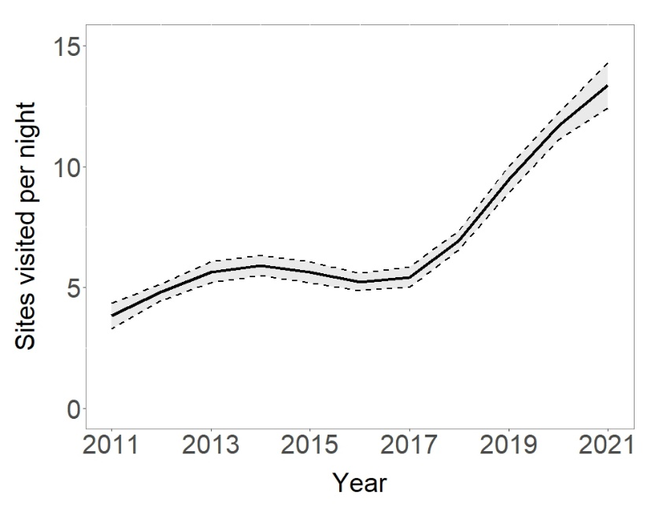
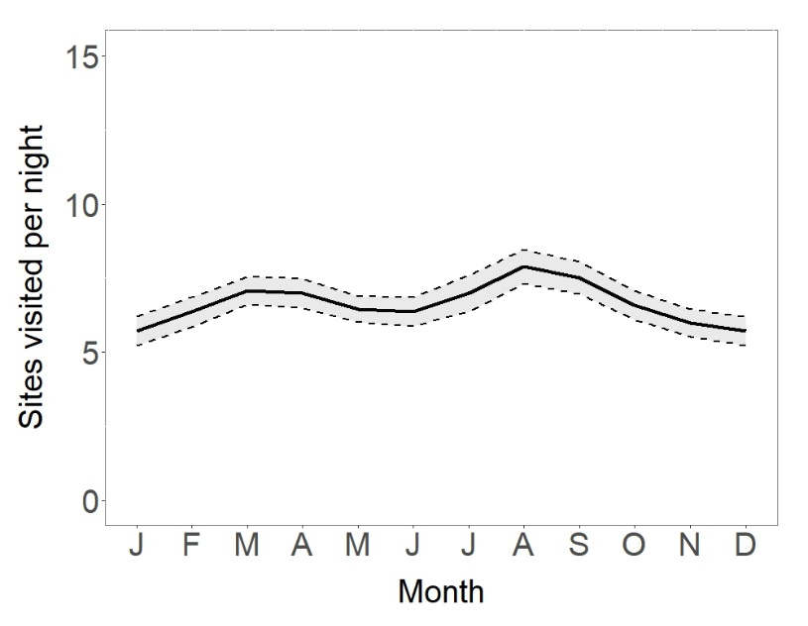

Figure S2: Expected annual and monthly number of deer killed per site-visit by professional vehicle-based shooters of rusa deer during the Illawarra Wild Deer Management Program in Wollongong LGA, eastern Australia, 2011–2021. Model outputs are means (solid line) and 95% confidence intervals (grey). Years start in May and end in April.

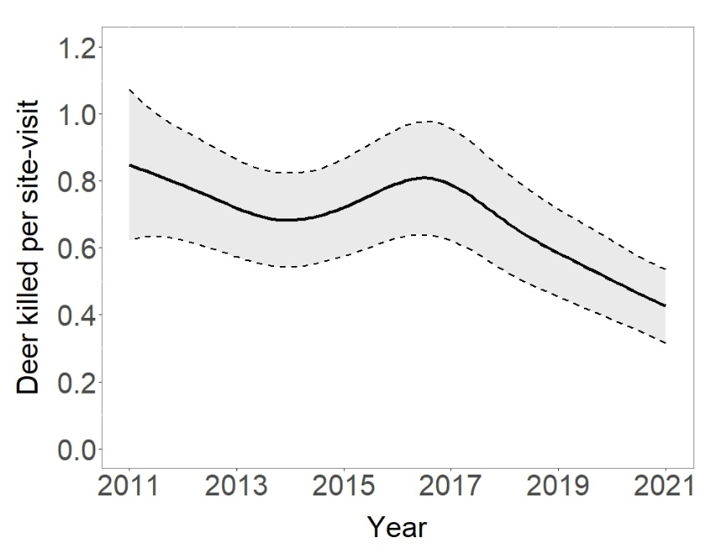
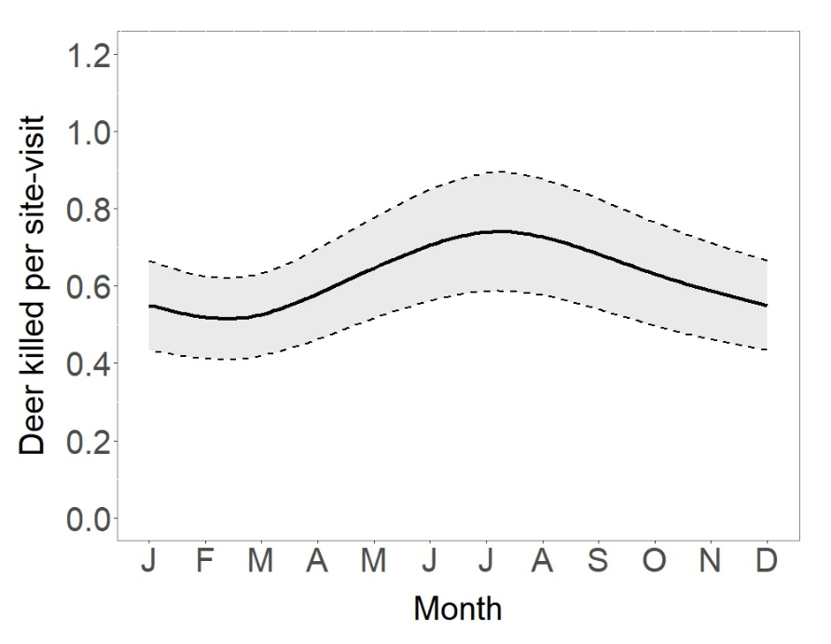

Appendix II: Rusa deer relative abundance.
Figure S1. Expected faecal pellet count (April) during the Illawarra Wild Deer Management Program in Wollongong LGA, eastern Australia, 2011–2021. Years start in May and end in April.
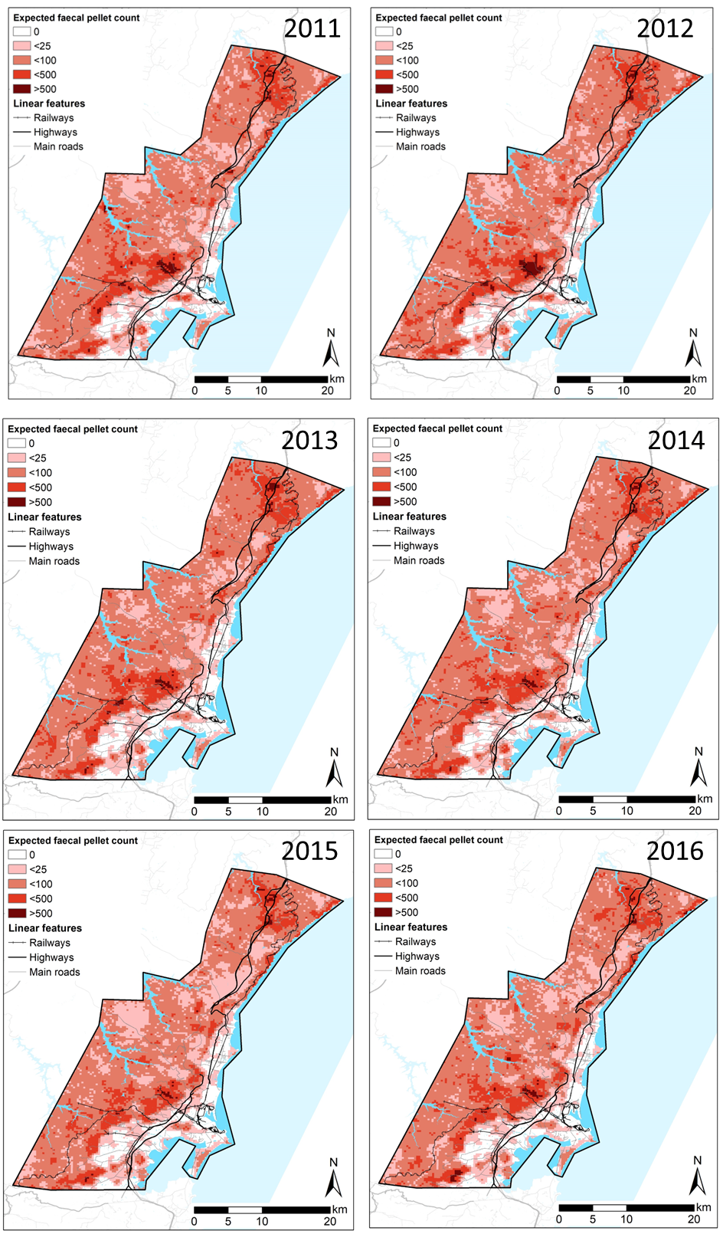
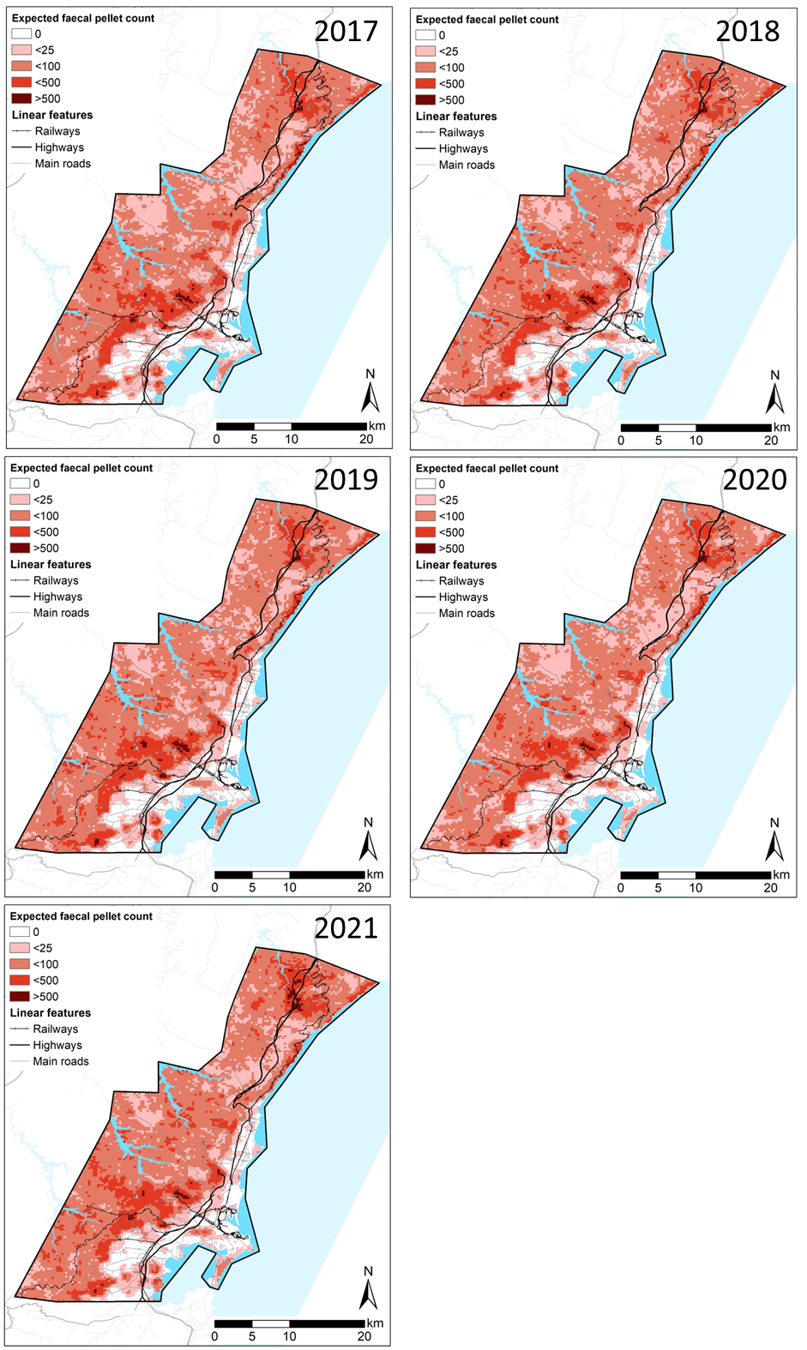

Appendix III: Expected probabilities of resident complaints.
Figure S1. Expected annual probabilities of a resident complaint about rusa deer being lodged during the Illawarra Wild Deer Management Program in Wollongong LGA, eastern Australia, 2011–2018. Years start in May and end in April.
