Supplementary Material Appendix B: Results

Supplementary Table B1. Summary table of carp data available for each Australian jurisdiction. Note that for Western Australia only distributional data were available.
State | Number of projects | Year range | Number sites | Number carp caught | Number individual carp  mass
ACT | 8 | 2007–2018 | 36 | 72820 | 1654
NSW | 71 | 1995–2018 | 2673 | 180153 | 16271
QLD | 17 | 2001–2018 | 390 | 93158 | 8995
SA | 18 | 1994–2018 | 163 | 103424 | 493
TAS | 1 | 2016–2016 | 1 | 987 | 775
VIC | 38 | 1999–2018 | 1568 | 123603 | 8138
WA | N/A | 2018 | N/A | N/A | N/A
Total | 153 | 1994–2018 | 4831 | 574145 | 36326

Supplementary Table B2. Estimated conversion factors for converting CPUE (no/h) to carp density (no/ha) for each aquatic habitat type from a bGLMM.

Habitat | Log-scale |  |  | Raw scale
 | Estimate ± SE | 95%CrI |  | Estimate | 95%CrI
Perennial River <50 m | 0.6 ± 0.2 | (0.2, 1) |  | 1.8 | (1.2, 2.7)
Perennial River >50 m | 1.2 ± 0.5 | (0.3, 2.1) |  | 3.3 | (1.3, 8.2)
Non perennial (Waterhole) | 1.5 ± 0.3 | (0.9, 2.2) |  | 4.5 | (2.5, 9.0)
Wetland | 1 ± 0.2 | (0.5, 1.4) |  | 2.7 | (1.6, 4.1)

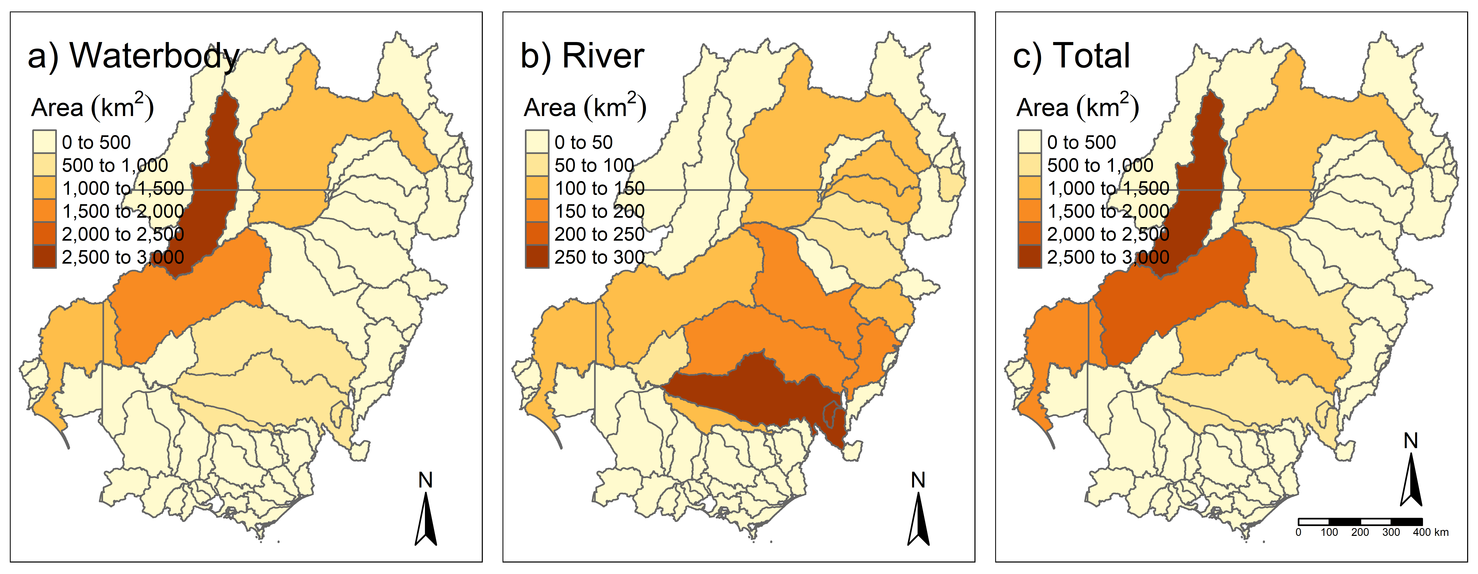
Supplementary Fig. B1. Estimates of the area (km²) of habitats occupied by carp, summarised by river basin. Panels represent area of: (a) waterbody habitat, (b) river habitat, and (c) waterbody and river combined.

Supplementary Fig. B2. Relationship between scaled efCPUE for carp and the six most influential covariates of rivers. These are marginal relationships and hence smooth over potential interactions among variables. Descriptions of river covariates are given in Supplementary Table A4. Note – sp_l3 refers to the third nested level of spatial areas.
Supplementary Fig. B3. Effects of key variables on predicted average carp mass for rivers. Each panel shows the fitted relationship with 95%CrI (grey shading) and standardised by the mean.

Supplementary Fig. B4. Estimated conversion factor for each aquatic habitat grouping. River habitats were grouped by width. Error bars are 95%CrI. Carp density is no/ha and efCPUE is no/h. As an example, if a CPUE of 10 carp was sampled from a wetland using standardised electrofishing (1080 seconds of electrofishing effort), the efCPUE = 10 x 3,600/1,080 = 33.3 (no/h). Then, using the conversion factor of 2.6, the estimated carp density at that site = 33.3 x 2.6 = 86.6 no/ha.

Supplementary Fig. B5. CPUE estimates for (a) lakes and (b) storages. The lake plot shows mean CPUE for each lake zone (distance from shore). The storage plot shows mean CPUE for each depth zone, separated by net depth (surface, midway, bottom). Points are model estimates with 95%CrI. The near shore net (depth zone 2) is shown in each panel for comparison.

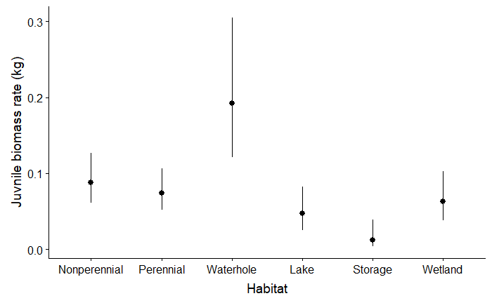

Supplementary Fig. B6. Juvenile biomass rates for each aquatic habitat type. Non-perennial and perennial refer to the rivers. Estimates were obtained by setting the other variables at their means. Error bars are 95%CrI.

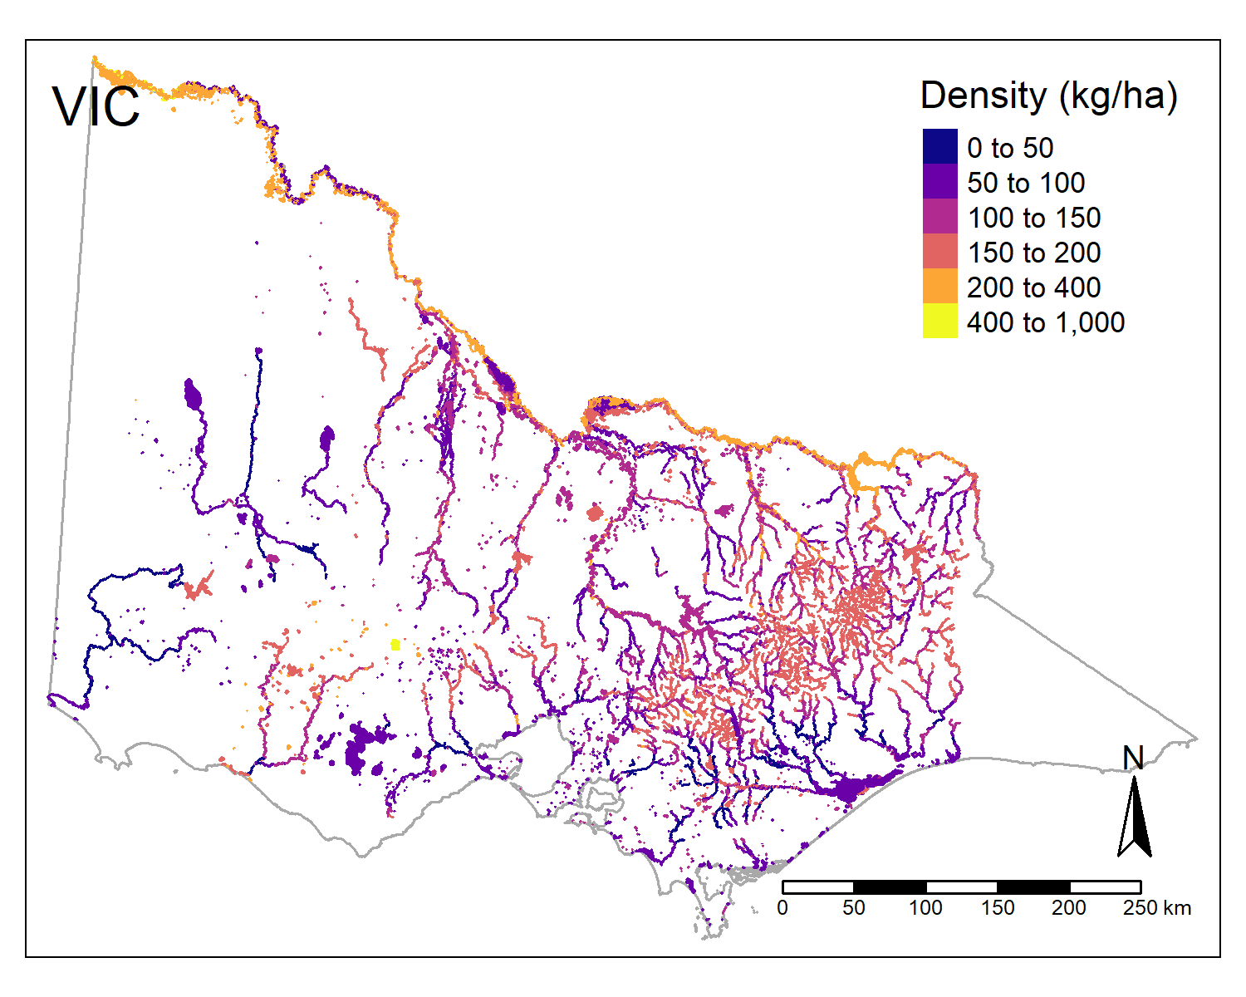
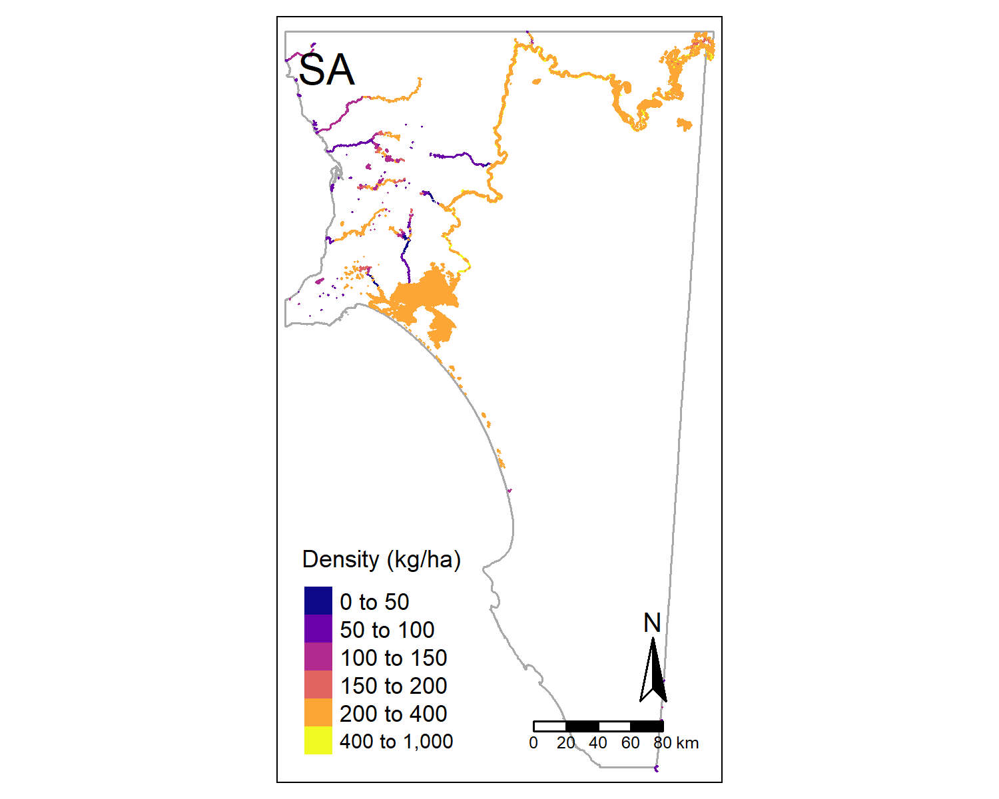
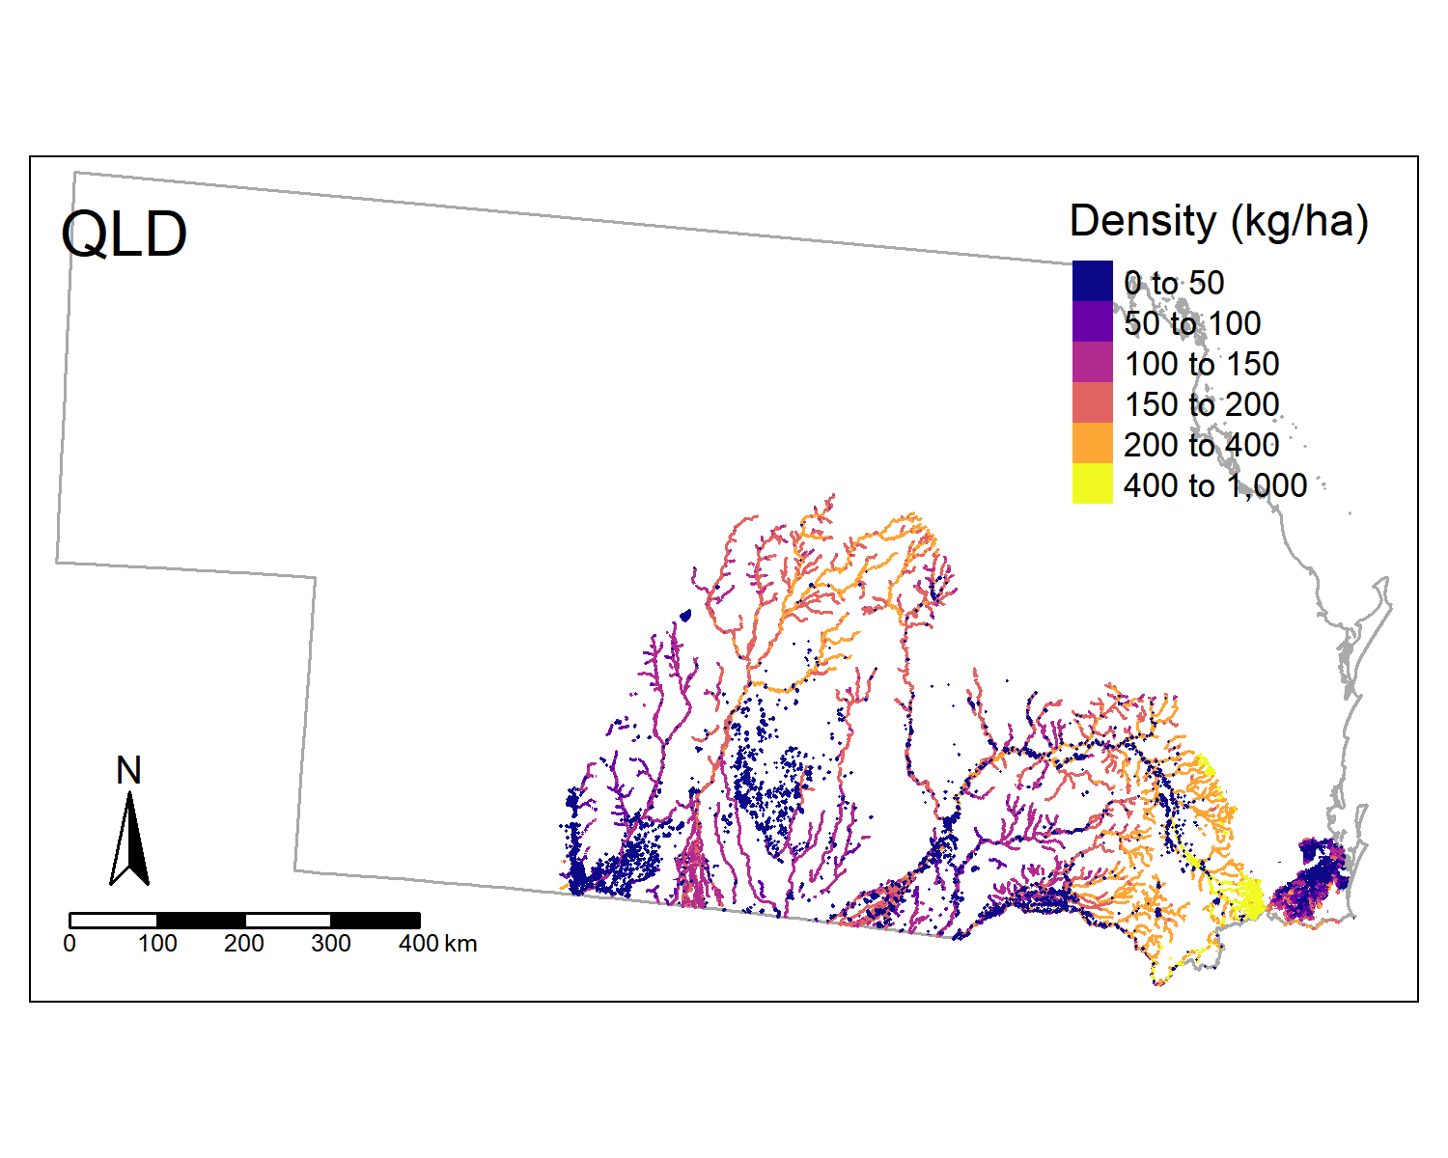
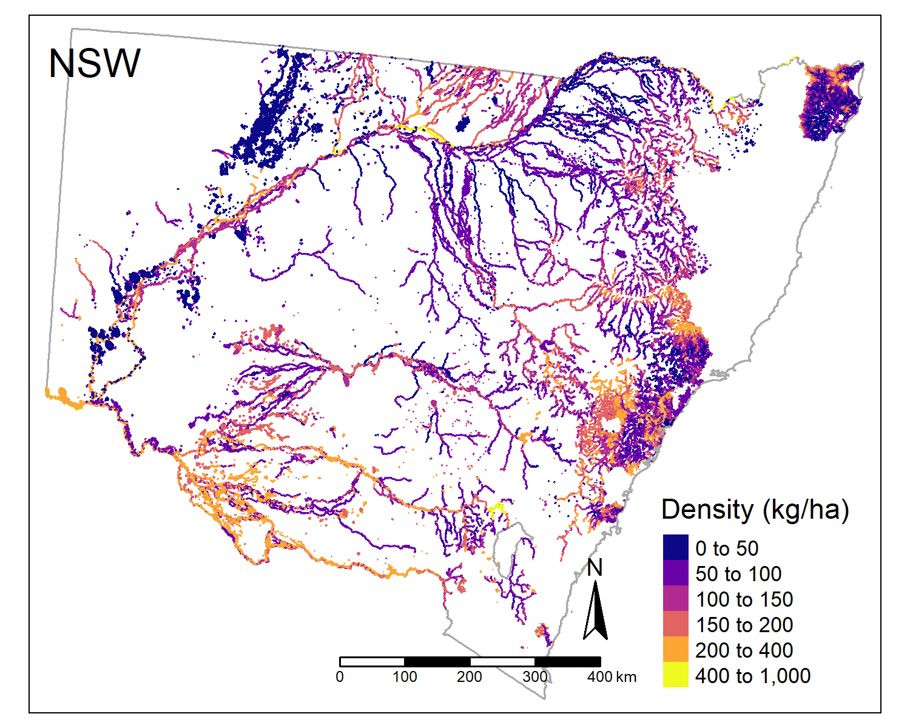
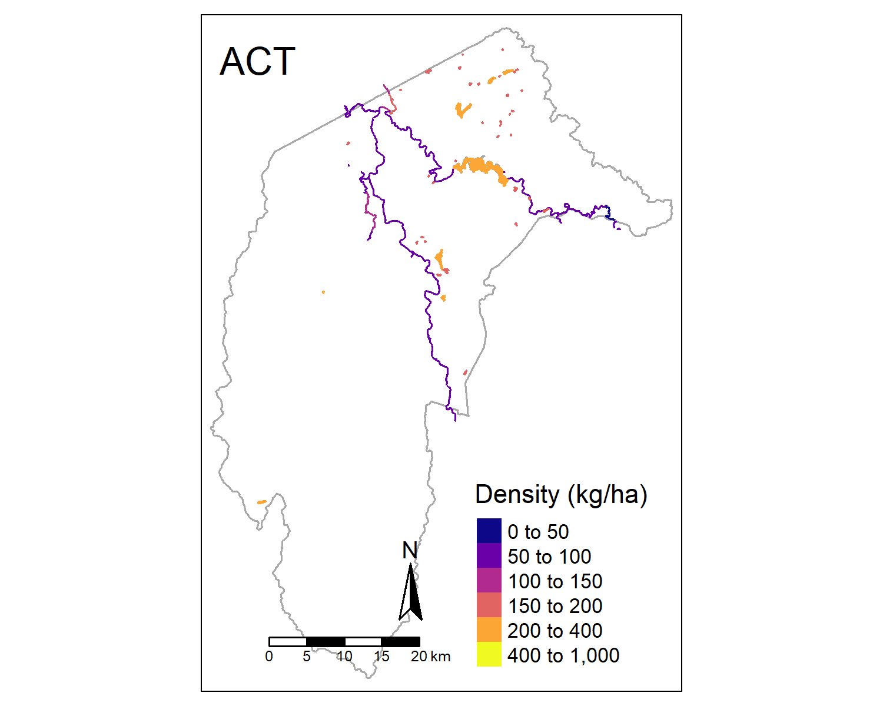
Absent

Absent

Supplementary Fig. B7. Predicted biomass density (kg/ha) of carp for each Australian state and territory. Note that Western Australia and Tasmania are excluded as these areas were not modelled and carp are absent in the Northern Territory. Large geographic areas where carp remain ‘absent’ are indicated for eastern Victoria and north-eastern NSW.

