SUPPLEMENTARY TABLES AND FIGURES

Hyperspectral imaging predicts macadamia nut-in-shell and kernel moisture using machine vision and learning tools

Michael B. Farrarª*, Reza Omidvar^{b}, Joel Nicholsª, Daniele Pelliccia^{c}, Suhad Al-Khafaji^{d}, Iman Tahmasbian^{ae}, Nimanie Hapuarachchiª, Shahla Hosseini Baiª

Supplementary Table S1: Efficiency of machine vision to automatically detect regions of interest (ROI) and extract mean spectral reflectance from hyperspectral images.
Sample type | Nut-in-shell |  |  |  | Cracked kernel
Image orientation | Image 1 |  | Image 2 |  | Base-up |  | Base-down
Number of images processed | 485 |  | 485 |  | 529 |  | 529
Successful automatic detection | 473 (97.53%) |  | 468 (96.49%) |  | 512 (96.78%) |  | 497 (93.95%)
Automatic detection replacement | 12 (2.47%) |  | 17 (3.51%) |  | 17 (3.21%) |  | 32 (6.05%)
Accuracy rate (%) are presented inside parenthesis

Supplementary Table S2: Important wavelengths selected for use in PLSR models to predict macadamia nut-in-shell and kernel moisture (%) concentration
Sample type | Selection method | Number | Wavelengths bands (nm) selected
Nut-in-shell | β-coefficient filtering during PLSR | 85 | 403.28, 404.59, 405.9, 407.2, 408.52, 409.82, 411.14, 412.44, 422.92, 453.09, 462.29, 464.92, 478.07, 499.14, 501.78, 518.92, 520.24, 521.56, 549.32, 550.64, 551.96, 561.23, 571.83, 745.2, 746.54, 749.22, 759.97, 770.72, 773.42, 774.76, 812.47, 813.82, 815.18, 816.53, 832.72, 846.24, 847.59, 876.02, 877.37, 878.72, 880.08, 881.44, 882.79, 884.15, 885.5, 886.86, 888.21, 889.57, 890.93, 892.28, 893.64, 901.78, 903.14, 904.5, 905.86, 907.21, 911.29, 912.65, 914.01, 915.36, 916.72, 918.08, 919.44, 920.8, 922.16, 933.04, 946.65, 953.46, 954.82, 956.19, 957.55, 958.91, 960.28, 961.64, 963, 964.36, 965.73, 967.09, 968.46, 969.82, 971.18, 972.55, 973.91, 975.28, 993.03
 | β-coefficient filtering during PLSR + select 10 with largest magnitude | 10 | 759.97, 877.37, 878.72, 880.08, 953.46, 954.82, 956.19, 958.91, 961.64, 965.73
Kernel | β-coefficient filtering during PLSR | 140 | 399.36, 400.66, 405.9, 407.2, 408.52, 413.76, 415.06, 416.37, 445.22, 471.49, 472.81, 474.12, 483.34, 484.65, 492.55, 493.87, 500.46, 501.78, 503.09, 504.41, 505.73, 507.05, 508.37, 514.96, 516.28, 517.6, 536.09, 537.41, 541.38, 542.7, 544.03, 545.35, 546.67, 547.99, 553.29, 554.61, 555.93, 569.17, 570.5, 571.83, 573.15, 574.47, 575.8, 577.12, 582.43, 583.76, 626.26, 651.57, 652.9, 662.24, 663.57, 664.9, 666.24, 682.26, 683.6, 714.36, 715.7, 718.38, 722.4, 726.42, 743.86, 747.88, 754.6, 762.66, 764, 765.35, 769.38, 770.72, 772.08, 773.42, 782.84, 804.38, 807.08, 816.53, 819.22, 830.02, 834.08, 836.78, 839.48, 847.59, 848.94, 853, 859.76, 861.12, 862.47, 866.54, 869.24, 880.08, 885.5, 886.86, 889.57, 892.28, 896.36, 903.14, 907.21, 908.57, 915.36, 918.08, 919.44, 920.8, 922.16, 923.52, 924.88, 926.24, 927.6, 928.96, 930.32, 931.68, 941.2, 943.93, 945.29, 946.65, 948.01, 949.38, 950.74, 953.46, 954.82, 956.19, 957.55, 958.91, 960.28, 961.64, 963, 964.36, 965.73, 967.09, 968.46, 969.82, 971.18, 972.55, 973.91, 975.28, 978.01, 979.37, 980.74, 982.1, 984.83, 990.3, 991.66, 994.4
 | β-coefficient filtering during PLSR + select 10 with largest magnitude | 10 | 782.84, 948.01, 949.38, 958.91, 960.28, 961.64, 963.00, 964.36, 965.73, 967.09

Supplementary Fig. S1
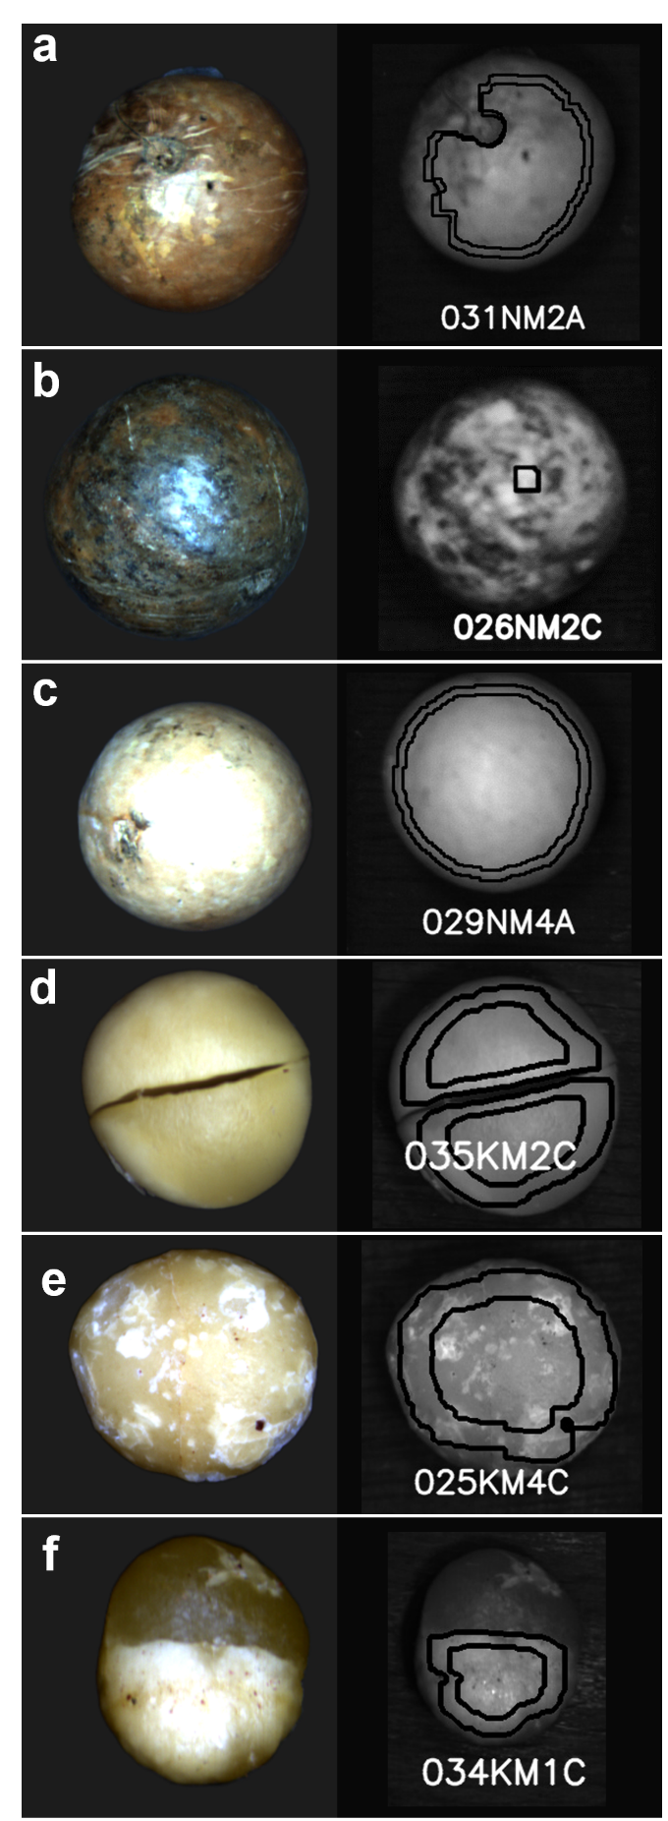
Supplementary Fig. S1 Pseudo RGB (left) and greyscale image showing smaller or duplicate automatic detection boundaries (right) of samples problematic for automatic detection using computer vision: (a) micropyle and physical deformation on nut-in-shell surface; (b) stain due to oil leak on nut-in-shell surface; (c) albino nut-in-shell surface colour; (d) kernel with split cotyledon; (e) kernel with black spot mould on surface; and (f) kernel breakdown following damage to the shell.

Conditions that impeded successful automatic identification and data extraction using machine vision software
Nut-in-shell with obvious physical deformation and/or deformation at the micropyle (Supplementary Fig. S1a), or nuts darkened by oil or mould (Supplementary Fig. S1b) were problematic for automatic extraction using band reference 375 (900 nm). In total 3% of nut-in-shell and 4.6% kernel samples, were not detected automatically. Features that impeded automatic detection for nut-in shell samples included: physical deformation and/or a distinctive micropyle (Supplementary Fig. S1a); shell darkened by oil, mould or fungal growth (Supplementary Fig. S1b); and other surface anomalies including white albino colouring (Supplementary Fig. S1c) (AMS, 2021). Additionally, the exact location of the micropyle within an image can also impede extraction from all visible pixels and therefore future studies should investigate if 1) micropyle presence/absence, and 2) position in the nut orientation significantly affects model prediction accuracy. Macadamia shells can contain up to 2% oil content which can encourage fungal growth on moist shells and this process should be considered when developing computer visions systems for macadamia nut-in-shell (Walton and Wallace, 2011). Features that impeded automatic detection of kernels included: 1) separation of the cotyledons (Supplementary Fig. S1d); 2) impacted shell during cracking (Supplementary Fig. S1e) and; 3) kernel breakdown following damage to the shell (Supplementary Fig. S1f) (AMS, 2021; J. Michael (personal communication, December 18, 2023); J. Michael (personal communication, May 9, 2024)).

References
AMS, 2021. Kernel Assessment Manual. Australian Macadamia Society, Lismore, p. 51.
J. Michael (personal communication - Defected kernels from hyperspectral images, December 18, 2023).
J. Michael (personal communication - Defected kernels from hyperspectral images, May 9, 2024).
Walton, D.A., & Wallace, H.M. (2011). Quality changes in macadamia kernel between harvest and farm‐gate. J. Sci. Food Agric. 91, 480-484.

