**Pre- and post-flowering impacts of natural heatwaves on yield components in wheat**

Najeeb Ullaha,1, Brian Collinsb,2, Jack Christophera, Troy Frederiksb, Karine Chenua,*

*a The University of Queensland, Queensland Alliance for Agriculture and Food Innovation (QAAFI), Leslie Research Facility, 13 Holberton Street, Toowoomba, QLD 4350, Australia*

*b Department of Agriculture and Fisheries, 13 Holberton Street, Toowoomba, QLD 4350, Australia*

*\* Corresponding author:* [*karine.chenu@uq.edu.au*](mailto:karine.chenu@uq.edu.au)

*1 Present address:Agricultural Research Station, Office of VP for Research & Graduate Studies, Qatar University,   
Doha 2713, Qatar*

*2 Present address:* *Centre for Sustainable Agricultural Systems, University of Southern Queensland Toowoomba, Queensland 4350, Australia*

**Table S1** Characteristics of wheat genotypes used in the study. For a given year, the genotypes tested with the photoperiod-extension method (PEM) and in conventional plots were the same, except for the PEM trial with quadrate harvest in 2020 (when only 20 selected genotypes were used).

|  |  |  |  |  |  |
| --- | --- | --- | --- | --- | --- |
| **Genotypes** | **Type** | **Pedigree** | **Characteristics** | **Reference** | **Year tested** |
| Berkut | Cultivar | Irena/Baviacora-M-92//Pastor | Heat tolerance | Thistlethwaite et al. (2020) | 2018, 2019, 2020 |
| Corack | Cultivar | MACHETE/84W129-504*2/5/VICAM S 71//CIANO F 67/SIETE CERROS/ 3/KAL/BB/4/TM56 | Australian Premium White (APW) variety | GRDC (2018) | 2018, 2019 |
| Dharwar Dry | Cultivar | DWR39/C306//HD2189 | Drought tolerant, stay-green phenotype | Manschadi et al. (2008) | 2018, 2019 |
| Drysdale | Cultivar | Hartog*3/Quarrion | Superior transpiration efficiency | Fletcher et al. (2018); Richard et al. (2015) | 2018, 2019, 2020 |
| EGA Gregory | Cultivar | Pelsart/2*Batavia | Long-season elite cultivar with broad adaptation |  | 2018, 2019, 2020 |
| EGA Wylie | Cultivar | INIA F 66 / GAMUT// COOK/3/JUPATECO F 73/TR 59 | Disease resistance | Zheng et al. (2014) | 2018, 2019, 2020 |
| FAC10-16 | Elite breeding line | 10CB-F/W234 | Disease resistance | Dinglasan et al. (2016) | 2018, 2019 |
| Fang | Cultivar | ANNUELLO/2*STYLET | Heat tolerance | Skylas et al. (2002) | 2018 |
| GK ARON/AG | Elite breeding line | GK ARON/AG SECO 7846//2180 /4/2*MILAN/KAUZ//PRINIA/3/BAV92 | Heat tolerance | Thistlethwaite et al. (2020) | 2018, 2019 |
| GOU/Sokoll | Elite breeding line | GOUBARA-1/2*Sokoll | Heat tolerance | Thistlethwaite et al. (2020) | 2018, 2019, 2020 |
| Hartog | Cultivar | Vicam 71//Ciano 's'/Siete Cerros/3/Kalyansona/Bluebird | Drought sensitive, senescent phenotype | Christopher et al. (2008); Richard et al. (2015) | 2018, 2019, 2020 |
| Janz | Cultivar | 3-AG-3/4*CONDOR//COOK | Drought sensitive, senescent phenotype | Christopher et al. (2008) | 2018, 2019, 2020 |
| Mace | Cultivar | Wyalkatchem/Stylet//Wyalkatchem | Benchmark cultivar for yield across southern Australian cropping regions | GRDC (2018) | 2018, 2019, 2020 |
| Mace-177 | Elite breeding line | Mace/Seri-M82 | Drought adaptation | Christopher et al. (2021) | 2018, 2019 |
| PBW343 | Cultivar | NORD-DESPREZ/VG-1944//KALYANSONA//BLUEBIRD/3/YACO(SIB)/4/VEERY-5 | Heat tolerant | Thistlethwaite et al. (2020) | 2018 |
| RIL114 | Elite breeding line | UQ01484/RSY10//H45 | Pre-harvest sprouting tolerance | Hickey et al. (2009) | 2018, 2019 |
| SB003 | Elite breeding line | Seri-M82/Babax | Heat sensitive, low stem water soluble carbohydrates | Dreccer et al. (2009); Olivares-Villegas et al. (2007); Rattey et al. (2009); Ullah and Chenu (2019) | 2019, 2020 |
| SB062 | Elite breeding line | Seri-M82/Babax | Heat tolerant, high stem water soluble carbohydrates | Dreccer et al. (2009); Olivares-Villegas et al. (2007); Rattey et al. (2009); Ullah and Chenu (2019) | 2018, 2019, 2020 |
| Scout | Cultivar | Sunstate/QH71-6//Yitpi | Elite cultivar with broad adaptation |  | 2018, 2019, 2020 |
| Scout-136 | Elite breeding line | Scout/RIL114 | Drought sensitive, senescent phenotype | Christopher et al. (2021) | 2018, 2019, 2020 |
| Seri-M82 | Elite breeding line | Kavkaz/4/Saric F 70///Lerma Rojo 64A/Inia F66//Inia F66/Yecora F70/5/II-26992 | Dense root system, stay-green phenotype | Christopher et al. (2008); Olivares-Villegas et al. (2007) | 2018, 2019, 2020 |
| Sokoll | Cultivar | Pastor/3/Altar84/AE.SQ (TR.TA)//OPATA-M-85 | Heat tolerant | Thistlethwaite et al. (2020) | 2018, 2019, 2020 |
| Sokoll//FRTL | Elite breeding line | SOKOLL//FRTL/2*PIFED | Heat tolerant | Thistlethwaite et al. (2020) | 2018, 2019, 2020 |
| Spitfire | Cultivar | Drysdale/Kukri | Heat tolerant, high grain protein content |  | 2018, 2019 |
| SSrT17 | Elite breeding line | Double backcross for the TIN gene into the free-tillering  Silverstar background | Low tillering (*tin1* allele), big grains | Mitchell et al. (2008) | 2019 |
| SSrW35 | Elite breeding line | Double backcross for the TIN gene into the free-tillering  Silverstar background | High tillering (wild type allele) | Mitchell et al. (2008) | 2019 |
| Suntop | Cultivar | Sunco/2*Pastor//SUN436E | Elite cultivar with broad adaptation; superior transpiration efficient | Fletcher et al. (2018); Chenu et al. (2018); Collins et al. (2021); Richard et al. (2015) | 2018, 2019, 2020 |
| Suntop_1 | Elite breeding line | Suntop /Dharwar Dry | Drought tolerant, stay-green phenotype | Christopher et al. (2021) | 2018, 2019 |
| Suntop _198 | Elite breeding line | Suntop/SB062 | Drought tolerant, stay-green phenotype | Christopher et al. (2021) | 2018, 2019, 2020 |
| Suntop _52 | Elite breeding line | Suntop /Dharwar Dry | Drought tolerant, stay-green phenotype | Christopher et al. (2021) | 2018, 2019, 2020 |
| WH 542 | Cultivar | BJY/JUP//URES | Heat tolerant | Thistlethwaite et al. (2020) | 2018 |
| Yitpi | Cultivar | Condor/Gabo | Long coleoptile, very susceptible to yellow spot |  | 2018, 2019, 2020 |
| ZWB10-37 | Elite breeding line | Tacupeto F2001/Brambling//Kiritati | High yield in CIMMYT-Australia-ICARDA Germplasm Evaluation | Dinglasan et al. (2016) | 2018, 2019, 2020 |
| ZWW10-128 | Elite breeding line | ESDA/KKTS | High yield in CIMMYT-Australia-ICARDA Germplasm Evaluation | Dinglasan et al. (2016) | 2018, 2019 |
| ZWW10-50 | Elite breeding line | Onix/4/Milan/Kauz//Prinia/3/BAV92 | High yield in the CIMMYT-Australia-ICARDA Germplasm Evaluation | Dinglasan et al. (2016) | 2018, 2019, 2020 |

**Table S2** Timing of key phenological developmental phases for wheat genotypes in PEM trials. Data from all the studied genotypes were collected at matched developed phases.

|  |  |  |  |  |  |  |  |
| --- | --- | --- | --- | --- | --- | --- | --- |
| Trial* | **Sowing** | **Tillering** | **Jointing** | **Booting** | **Heading** | **Anthesis** | **Maturity** |
| GAT18-s1 | 3-Jul-18 | 22-Jul-18 | 18-Aug-18 | 28-Aug-18 | 8-Sep-18 | 14-Sep-18 | 26-Oct-18 |
| GAT18-s2 | 31-Aug-18 | 14-Sep-18 | 6-Oct-18 | 14-Oct-18 | 20-Oct-18 | 24-Oct-18 | 27-Nov-18 |
| GAT19-s1 | 9-Jul-19 | 28-Jul-19 | 20-Aug-19 | 1-Sep-19 | 7-Sep-19 | 13-Sep-19 | 27-Oct-19 |
| GAT19-s2 | 3-Sep-19 | 17-Sep-19 | 6-Oct-19 | 16-Oct-19 | 23-Oct-19 | 1-Nov-19 | 6-Dec-19 |
| GAT20-s1 | 26-May-20 | 11-Jun-20 | 9-Jul-20 | 24-Jul-20 | 8-Aug-20 | 13-Aug-20 | 1-Oct-20 |
| GAT20-s2 | 4-Aug-20 | 23-Aug-20 | 16-Sep-20 | 23-Sep-20 | 2-Oct-20 | 7-Oct-20 | 14-Nov-20 |
| TOS19-s1 | 16-Jul-19 | 9-Aug-19 | 12-Sep-19 | 22-Sep-19 | 1-Oct-19 | 7-Oct-19 | 7-Nov-19 |
| TOS19-s2 | 6-Sep-19 | 23-Sep-19 | 18-Oct-19 | 27-Oct-19 | 1-Nov-19 | 7-Nov-19 | 12-Dec-19 |
| WAR18-s1 | 16-Jul-18 | 9-Aug-18 | 10-Sep-18 | 20-Sep-18 | 27-Sep-18 | 4-Oct-18 | 5-Nov-18 |
| WAR18-s2 | 12-Sep-18 | 28-Sep-18 | 20-Oct-18 | 28-Oct-18 | 3-Nov-18 | 7-Nov-18 | 10-Dec-18 |
| WAR20-s1 | 8-Jun-20 | 5-Jul-20 | 16-Aug-20 | 1-Sep-20 | 10-Sep-20 | 17-Sep-20 | 5-Nov-20 |
| WAR20-s2 | 12-Aug-20 | 29-Aug-20 | 1-Oct-20 | 10-Oct-20 | 18-Oct-20 | 23-Oct-20 | 1-Dec-20 |
| Thermal time since sowing (oCd) | | | | | | | |
| GAT18-s1 |  | 267 | 676 | 811 | 986 | 1090 | 1917 |
| GAT18-s2 |  | 252 | 653 | 808 | 944 | 1032 | 1880 |
| GAT19-s1 |  | 252 | 571 | 741 | 862 | 945 | 1788 |
| GAT19-s2 |  | 222 | 651 | 797 | 961 | 1138 | 1854 |
| GAT20-s1 |  | 293 | 678 | 884 | 1112 | 1182 | 2062 |
| GAT20-s2 |  | 290 | 708 | 856 | 1029 | 1133 | 1971 |
| TOS19-s1 |  | 270 | 721 | 915 | 1108 | 1237 | 1893 |
| TOS19-s2 |  | 315 | 838 | 1025 | 1137 | 1270 | 2039 |
| WAR18-s1 |  | 257 | 597 | 771 | 883 | 1003 | 1626 |
| WAR18-s2 |  | 289 | 679 | 846 | 968 | 1057 | 1762 |
| WAR20-s1 |  | 257 | 748 | 913 | 1046 | 1146 | 2098 |
| WAR20-s2 |  | 192 | 692 | 878 | 1006 | 1102 | 1974 |

*\** An identifier of the site denominates environments as Gatton (GAT), Tosari (TOS) or Warwick (WAR); the year of the trial, the time of sowing (s1 or s2), when applicable.

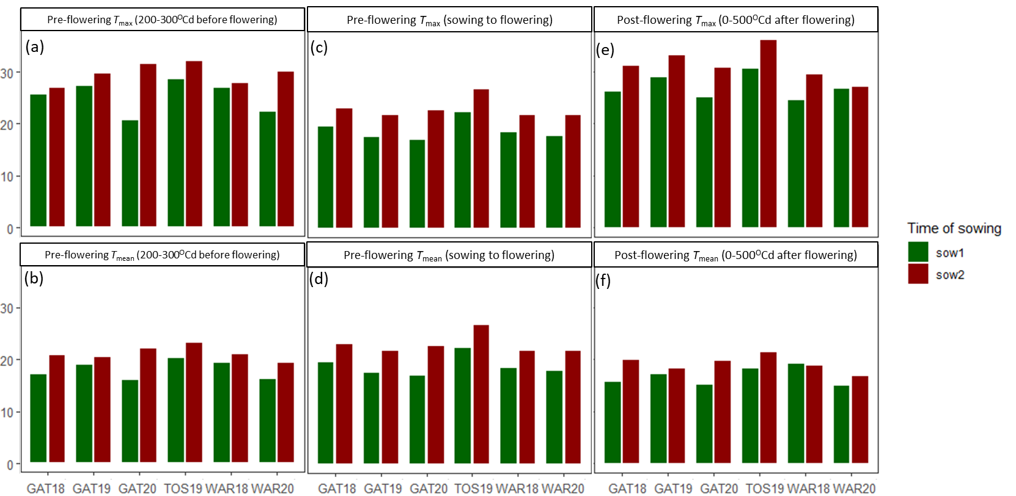

**Fig. S1** Intensity of heat experienced by wheat crops during sensitive developmental phases before (c, d) and after (a, b) flowering across trials and taggings in regard to average daily maximum temperature (Tmax; a, c, e) and mean daily temperatures (b, d, f), respectively. T1, 1st cohort of stems tagged at flowering, T2, 2nd cohort of stems tagged at flowering; T3, 3rd cohort of stems tagged at flowering.

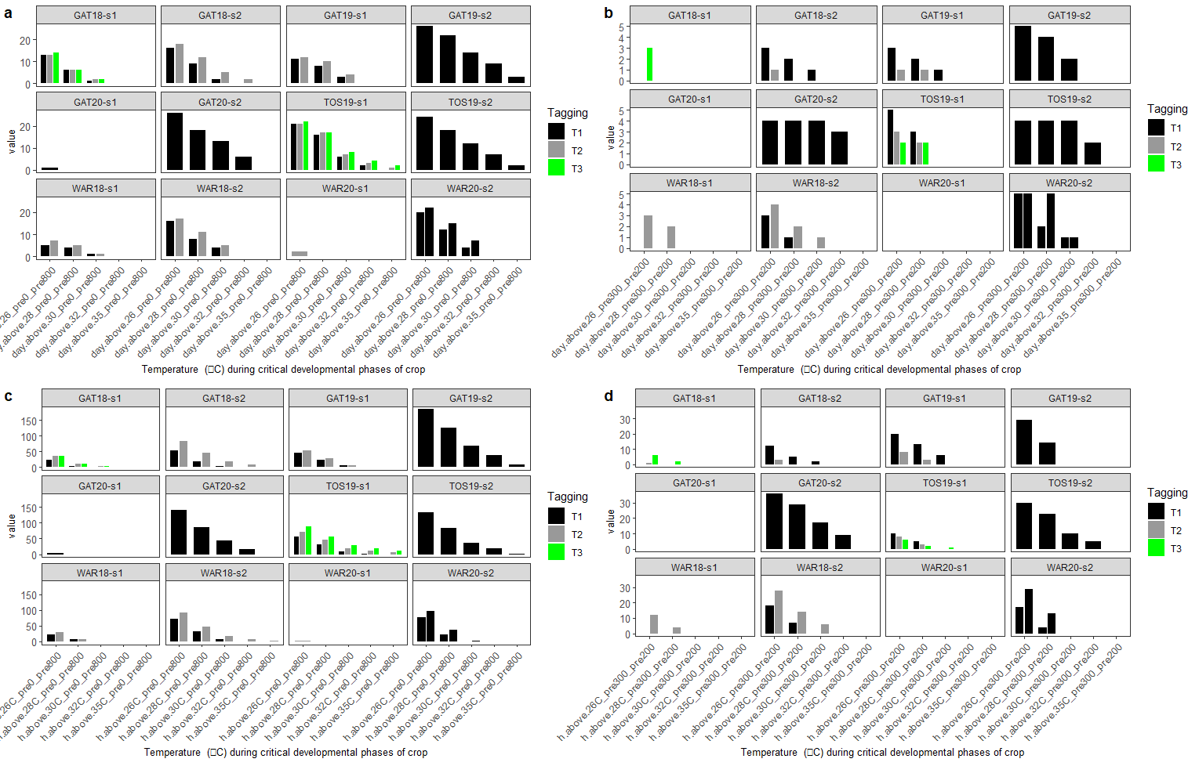

26 28 30 32 35

26 28 30 32 35

26 28 30 32 35

26 28 30 32 35

26 28 30 32 35

26 28 30 32 35

26 28 30 32 35

26 28 30 32 35

**Threshold temperature (oC) from 200 to 300oCd to flowering**

**Threshold temperature (oC) from sowing to flowering**

**Cumulative days > threshold**

**Cumulative hours > threshold**

(b)

(d)

(a)

(c)

**Fig. S2** Cumulative number of pre-flowering hot days (a, b) and heat hours (c,d) from sowing to flowering (a,c) and between 200 and 300oCd before flowering (b,d) for temperatures above threshold temperatures (ranging from 26 to 35oC) experienced by wheat crops in the studied environments.T1, 1st cohort of stems tagged at flowering; T2, 2nd cohort of stems tagged at flowering; T3, 3rd cohort of stems tagged at flowering.

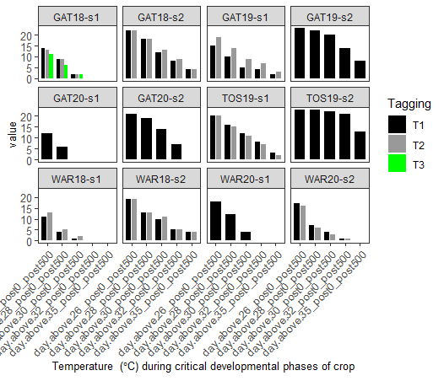

Cumulative days > threshold

26 28 30 32 35

26 28 30 32 35

26 28 30 32 35

26 28 30 32 35

Threshold temperature (oC) from 0 to 500oCd after flowering

Cumulative hours > threshold

Threshold temperature (oC) from 0 to 500oCd after flowering

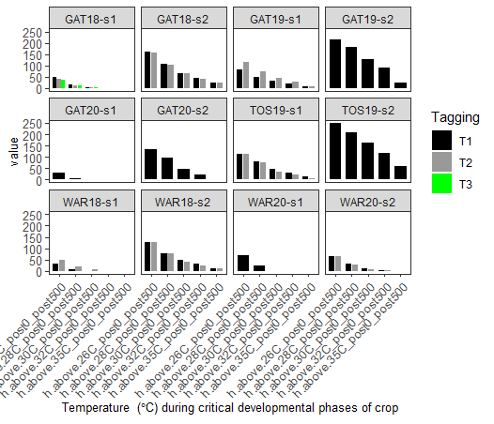

26 28 30 32 35

26 28 30 32 35

26 28 30 32 35

26 28 30 32 35

**HET3**

**HET3**

**HET2**

**HET1**

**HET1**

**HET2**

**HET2**

**HET2**

**HET2**

**HET2**

**HET1**

**HET1**

(b)

(a)

**HET3**

**HET2**

**HET1**

**HET1**

**HET2**

**HET2**

**HET2**

**HET2**

**HET2**

**HET1**

**HET1**

**HET3**

**Fig. S3** Cumulative post-flowering (0-500○Cd after flowering) hot days (a) and heat hours (b) with temperatures above threshold temperatures (ranging from 26 to 35oC) experienced by wheat crops in the studied environments. T1, 1st cohort of stems tagged at flowering; T2, 2nd cohort of stems tagged at flowering; T3, 3rd cohort of stems tagged at flowering. Environments were classified into three heat environment types (HETs, Fig. S3); (HET1, black label) heat environment type 1 corresponds to environments with 0 days or hours with temperature > 32○C between 0 and 500○Cd after flowering, while (HET2, blue coloured label) heat environment type 2 corresponds to 1-9 days or 1-49 of temperature > 32○C during the same period, and (HET3, red label) heat environment type 3 had more than 10 days or 50 hours of temperature > 32○C between 0 and 500○Cd after flowering.

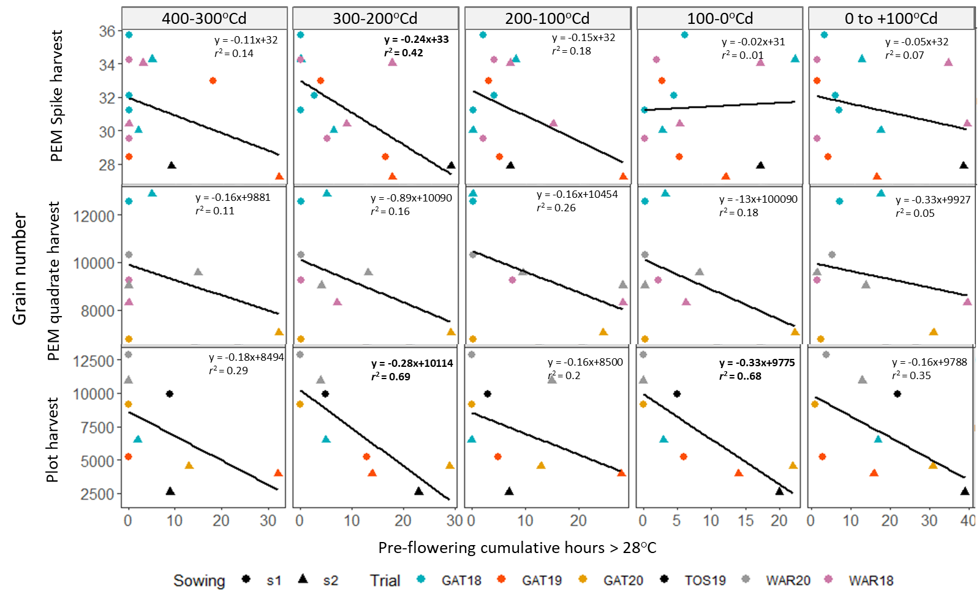

**Fig. S4** Changes in grain number in response to cumulated hours with temperature > 28○C at different periods of time (i.e. 300-400○Cd pre flowering, 200-300○Cd pre flowering, 100-200○Cd pre flowering, 0-100○Cd pre flowering, and 0-100○Cd post flowering). Data correspond to the mean of 20 - 32 genotypes with four independent replicates in each environment. Spike data are collected from the individual spikes (~20 for each replicate) exposed to heat at synchronised developmental stages. Quadrate data were collected by harvesting 0.5 m linear meter of plants tagged at synchronised flowering in the PEM. Plot data were collected from the whole conventional plots of naturally flowering genotypes (stage not synchronised during heatwaves). Quadrate and plot data are presented per unit area (m-2), and data for spike data correspond to the number of grains per spike. Regressions with equation presented in bold font at a *P* value < 0.05.

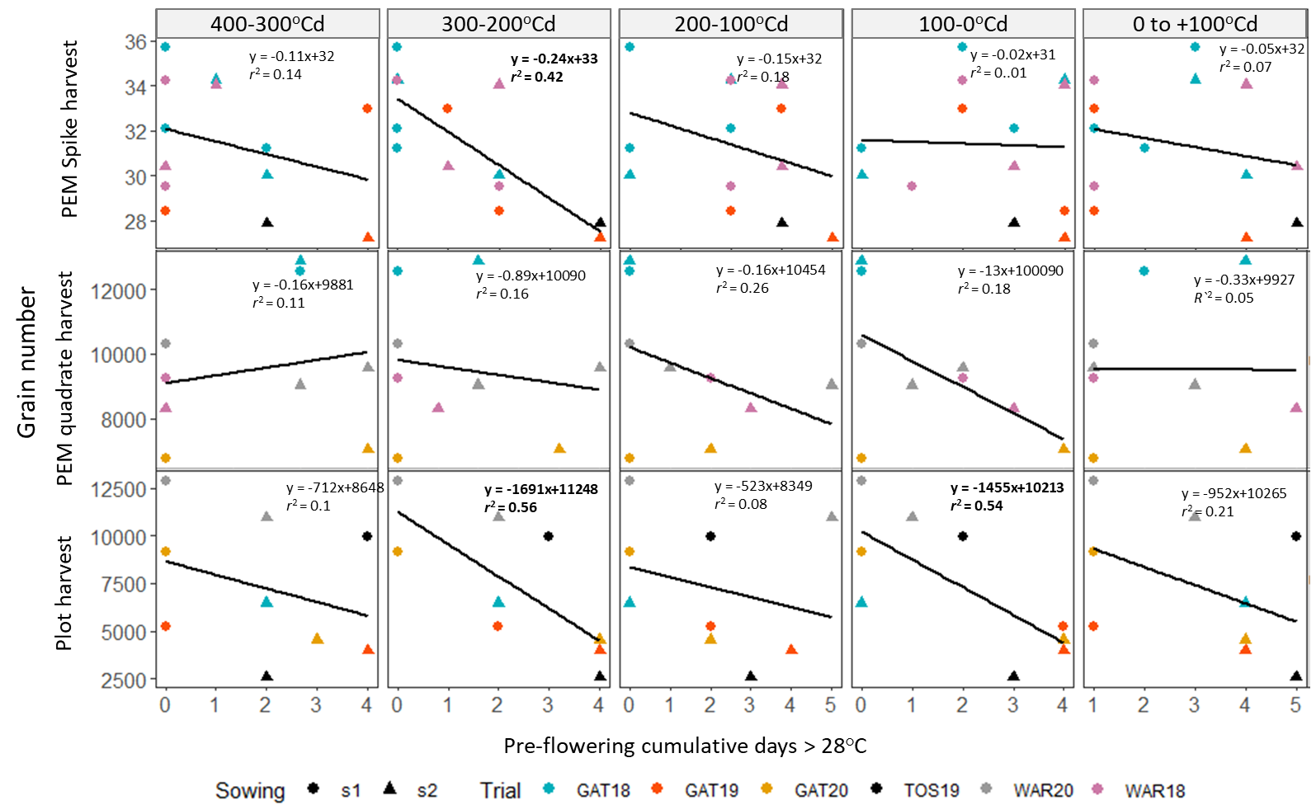

**Fig. S5** Changes in grain number in response to cumulated days with temperature > 28○C at different periods of time (i.e. 300-400○Cd pre flowering, 200-300○Cd pre flowering, 100-200○Cd pre flowering, 0-100○Cd pre flowering, and 0-100○Cd post flowering). Data correspond to the mean of 20 – 32 genotypes with four independent replicates in each environment. Spike data are collected from the individual spikes (~20 for each replicate) exposed to heat at synchronised developmental stages. Quadrate data were collected by harvesting 0.5 m linear meter of plants tagged at synchronised flowering in the PEM. Plot data were collected from the whole conventional plots of naturally flowering genotypes (stage not synchronised during heatwaves). Quadrate and plot data are presented per unit area (m-2), and data for spike data correspond to the number of grains per spike. Regressions with equation presented in bold font at a *P* value < 0.05.

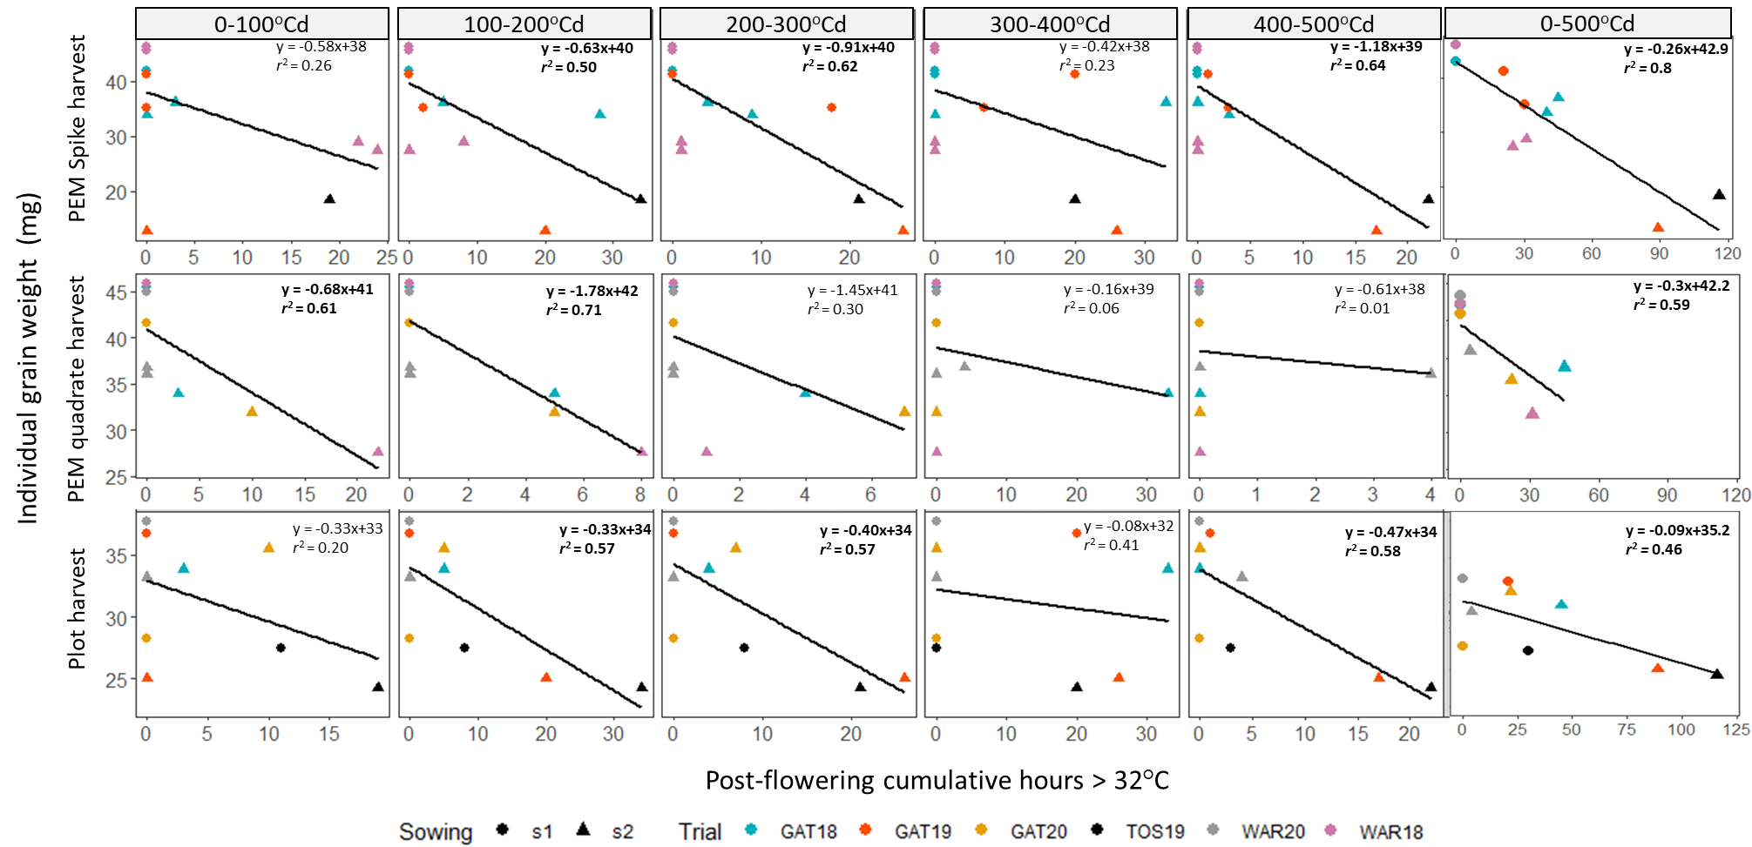

**Fig. S6** Changes in individual grain weight in response to cumulated hours with temperature > 32○C at different post-flowering periods (i.e. 0-100○Cd, 100-200○Cd, 200-300○Cd, 300-400○Cd, 400-500○Cd and the whole 0-500○Cd post-flowering period). Data correspond to the mean of 20 – 32 genotypes with four independent replicates in each environment. Spike data are collected from the individual spikes (~20 for each replicate) exposed to heat at synchronised developmental stages. Quadrate data were collected by harvesting 0.5 m linear meter of plants tagged at synchronised flowering in the PEM. Plot data were collected from the whole conventional plots of naturally flowering genotypes (stage not synchronised during heatwaves). Regressions with equation presented in bold font at a *P* value < 0.05.

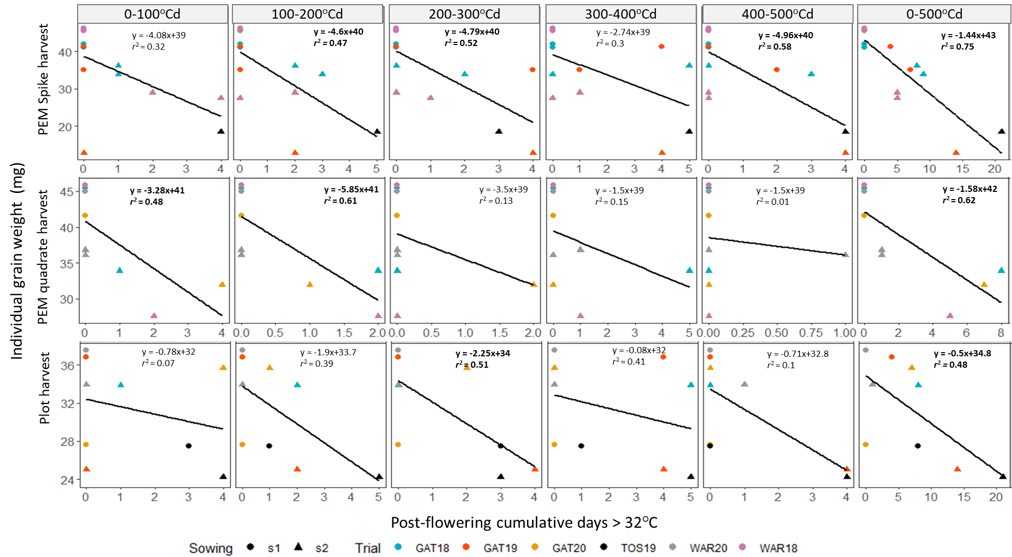

**Fig. S7** Changes in individual grain weight in response to cumulated days with temperature > 32○C at different post-flowering periods (i.e., 0-100○Cd, 100-200○Cd, 200-300○Cd, 300-400○Cd, 400-500○Cd and the whole 0-500○Cd post-flowering period). Data correspond to the mean of 20 – 32 genotypes with four independent replicates in each environment. Spike data are collected from the individual spikes (~20 for each replicate) exposed to heat at synchronised developmental stages. Quadrate data were collected by harvesting 0.5 m linear meter of plants tagged at synchronised flowering in the PEM. Plot data were collected from the whole conventional plots of naturally flowering genotypes (stage not synchronised during heatwaves). Regressions with equation presented in bold font at a *P* value < 0.05.

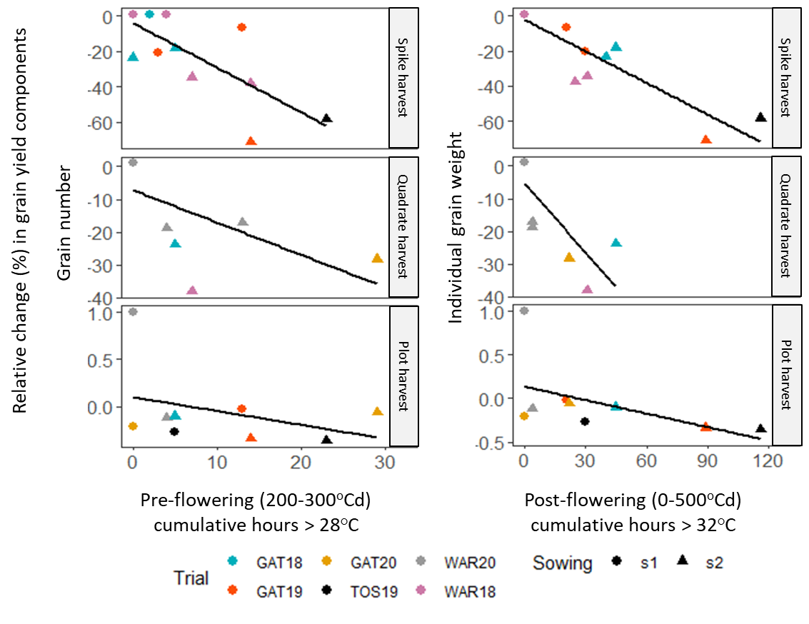

**Fig. S8** Relative changes in grain yield components in response to cumulative hot hours in the studied trials. Changes were calculated relative to potential trait values, which were estimated as the average of observed trait value in environments with no hot hours. Changes in grain number are presented in response to pre-flowering (300-400○Cd) hours with temperatures > 28○C. Changes in individual grain weight are presented for in response to post-flowering (0-500○Cd) hours with temperatures > 32○C.

**References**

Chenu K., Van Oosterom E.J., McLean G., Deifel K.S., Fletcher A., Geetika G., Tirfessa A., Mace E.S., Jordan D.R., Sulman R., Hammer G.L. 2018. Integrating modelling and phenotyping approaches to identify and screen complex traits: transpiration efficiency in cereals. J. Exp. Bot. 69: 3181-3194. http://dx.doi.org/10.1093/jxb/ery059

Christopher, J.T., Manschadi, A.M., Hammer, G.L., Borrell, A.K., 2008. Developmental and physiological traits associated with high yield and stay-green phenotype in wheat. Aust. J. Agric. Res. https://doi.org/10.1071/AR07193

Christopher, M., Paccapelo, V., Kelly, A., Macdonald, B., Hickey, L., Richard, C., Verbyla, A., Chenu, K., Borrell, A., Amin, A., Christopher, J., 2021. QTL identified for stay-green in a multi-reference nested association mapping population of wheat exhibit context dependent expression and parent-specific alleles. F. Crop. Res. 270, 108181. https://doi.org/10.1016/j.fcr.2021.108181

Collins, B., Chapman, S., Hammer, G., Chenu, K., 2021. Limiting transpiration rate in high evaporative demand conditions to improve Australian wheat productivity. in silico Plants. https://doi.org/10.1093/insilicoplants/diab006

Dinglasan, E., Godwin, I.D., Mortlock, M.Y., Hickey, L.T., 2016. Resistance to yellow spot in wheat grown under accelerated growth conditions. Euphytica. https://doi.org/10.1007/s10681-016-1660-z

Dreccer, M.F., van Herwaarden, A.F., Chapman, S.C., 2009. Grain number and grain weight in wheat lines contrasting for stem water soluble carbohydrate concentration. F. Crop. Res. 112, 43–54. https://doi.org/10.1016/j.fcr.2009.02.006

Fletcher, A., Christopher, J., Hunter, M., Rebetzke, G., Chenu, K., 2018. A low-cost method to rapidly and accurately screen for transpiration efficiency in wheat. Plant Methods. https://doi.org/10.1186/s13007-018-0339-y

GRDC, 2018. 2019 Wheat variety sowing guide for Western Australia 1–44.

Hickey, L.T., Dieters, M.J., DeLacy, I.H., Kravchuk, O.Y., Mares, D.J., Banks, P.M., 2009. Grain dormancy in fixed lines of white-grained wheat (*Triticum aestivum* L.) grown under controlled environmental conditions. Euphytica. https://doi.org/10.1007/s10681-009-9929-0

Manschadi, A.M., Hammer, G.L., Christopher, J.T., DeVoil, P., 2008. Genotypic variation in seedling root architectural traits and implications for drought adaptation in wheat (*Triticum aestivum* L.). Plant Soil. https://doi.org/10.1007/s11104-007-9492-1

Mitchell, J.H., Chapman, S., Rebetzke, G., Fukai, S., 2008. Increasing grain size and reducing screenings in wheat using a tiller inhibition gene – investigating grain morphology by image analysis, in: Conference, 14th Australian Agronomy (Ed.), .

Olivares-Villegas, J.J., Reynolds, M.P., McDonald, G.K., 2007. Drought-adaptive attributes in the Seri/Babax hexaploid wheat population. Funct. Plant Biol. https://doi.org/10.1071/FP06148

Rattey, A., Shorter, R., Chapman, S., Dreccer, F., Van Herwaarden, A., 2009. Variation for and relationships among biomass and grain yield component traits conferring improved yield and grain weight in an elite wheat population grown in variable yield environments. Crop Pasture Sci. https://doi.org/10.1071/CP08460

Richard, C.A.I., Hickey, L.T., Fletcher, S., Jennings, R., Chenu, K., Christopher, J.T., 2015. High-throughput phenotyping of seminal root traits in wheat. https://doi.org/10.1186/s13007-015-0055-9

Skylas, D.J., Cordwell, S.J., Hains, P.G., Larsen, M.R., Basseal, D.J., Walsh, B.J., Blumenthal, C., Rathmell, W., Copeland, L., Wrigley, C.W., 2002. Heat shock of wheat during grain filling: Proteins associated with heat-tolerance. J. Cereal Sci. https://doi.org/10.1006/jcrs.2001.0410

Thistlethwaite, R.J., Tan, D.K.Y., Bokshi, A.I., Ullah, S., Trethowan, R.M., 2020. A phenotyping strategy for evaluating the high-temperature tolerance of wheat. F. Crop. Res. https://doi.org/10.1016/j.fcr.2020.107905

Ullah, N., Chenu, K., 2019. Impact of post-flowering heat stress on stay-green and grain development in wheat. Proc. 2019 Agron. Aust. Conf.

Zheng, Z., Kilian, A., Yan, G., Liu, C., 2014. QTL conferring fusarium crown rot resistance in the elite bread wheat variety EGA Wylie. PLoS One. https://doi.org/10.1371/journal.pone.0096011