SUPPLEMENTARY MATERIALS

Microbial decomposition of organic matter and wetting-drying promotes aggregation in artificial soil but porosity increases only in wet-dry condition
Sheikh M.F. Rabbi^{1,2}*, Charles R. Warren¹, Brad Swarbrick³, Budiman Minasny¹, Alex B. McBratney¹, Iain M. Young^{1,4}
¹School of Life and Environmental Sciences, Faculty of Science, The University of Sydney, Camperdown, NSW 2006, Australia
² Department of Agriculture and Fisheries, Queensland Government, Toowoomba, QLD 4350, Australia
³School of Chemistry, Faculty of Science, The University of Sydney, Camperdown, NSW 2006, Australia
⁴Division of Biological and Environmental Science and Engineering, King Abdullah University of Science and Technology, Thuwal 23955, Saudi Arabia

*Corresponding author: sheikh.rabbi@sydney.edu.au

A1. Soil respiration

To track the changes in soil respiration during the incubation period, we measured the hourly respiration rate after 30, 60, 90 and 180 days of incubation (Fig. S1). The clear difference in respiration rate compared to the control became apparent after ~100 days of incubation. That was why we presented 180 days data when respiration rate was highest. Unlike natural soils in which respiration increases within hours-days of organic matter addition, the respiration rate started to increase only after ~100 days of incubation. We attributed this observation to the adaptation and development of microbial community in the artificial soil that received microbial inoculation. Because of long incubation period, experimental setup and number of treatments measured in the experiment it was not possible to log 180 days respiration data using non-dispersive infrared K30 CO₂ sensor to determine cumulative respiration. However, the differences in respiration rates between carbon treated soils (either glucose or cellulose) and control demonstrated the microbial decomposition of organic matter and microbial growth (Fig. 2b) in the carbon treated soils.

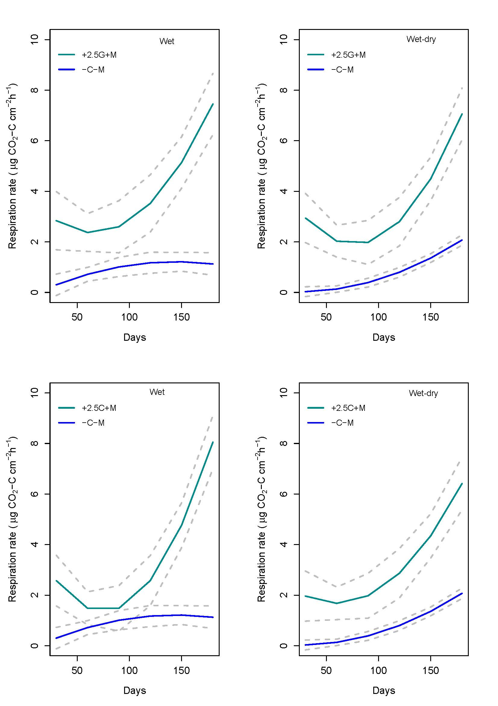

Fig. S1. Changes in soil respiration rate (expressed in µg CO₂-C cm⁻² h⁻¹) of aggregates during 180 days of incubation with 2.5% carbon in wet and wet-dry conditions. –C–M = no carbon + no microbe, +2.5G+M = 2.5% carbon as glucose + microbe, +2.5C+M = 2.5% carbon as cellulose + microbe. The broken lines around the solid lines are 95% confidence interval of mean.

A2. Raman spectra analysis
a. Microscope image with mapping grid
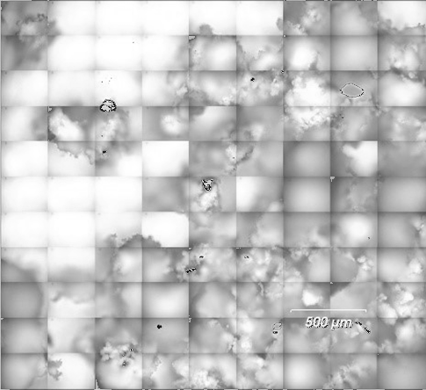
b. Principal component cluster 1(represents soil matrix)
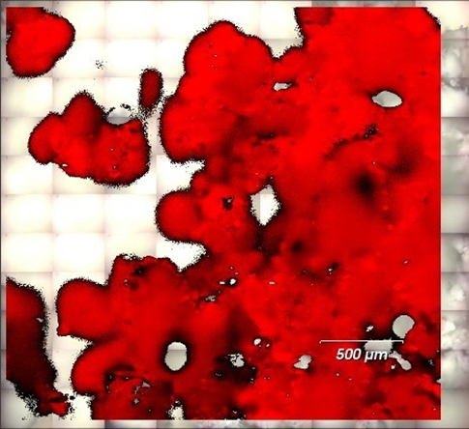

c. Principal component cluster 2 (represents soil matrix)
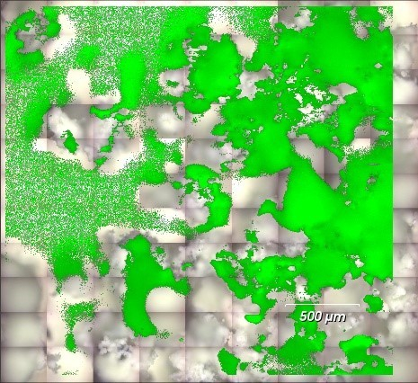

d. Principal component cluster 3 (represents organic molecules)
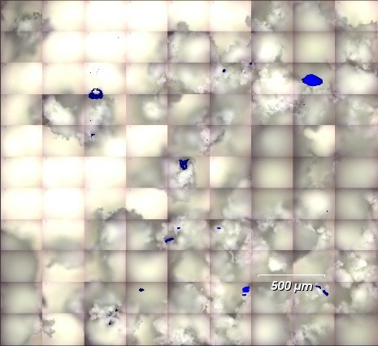

e. Principal component cluster 4 (represents soil matrix)
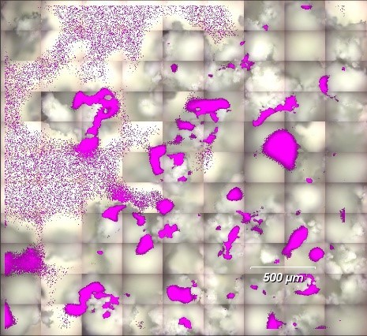
e. Composite false colour image with 4 clusters
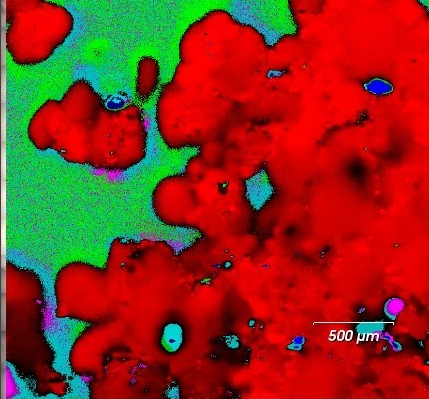

A3. X-ray microtomography scans of an aggregate

Video S1. Animated 2D slices of an aggregate in +2.5C+M treatment. White arrows indicating cellulose fibre at 8, 9, 11, 18, 31 and 41 seconds. Double-click the video icon to play.

Photo S1. Section of a slice in Video 1 showing cellulose fibre in soil.

